SWIFT SHIP TRACKER

VIVEKANANDHA COLLEGE OF TECHNOLOGY

FOR WOMEN [6130]

DHANUSRI . K  [613023104018] | TEAM LEADER | dhanusrikamaraj2006@gmail
PRIYADHARSHINI . M  [613023104084] | TEAM MEMBER | priyadharshini55412@gmail.com
SHALINI . K  [613023104097] | TEAM MEMBER | shalinipmk2005@gmail.com
SUJITHA . M  [613023104110] | TEAM MEMBER | sujithamuni0511@gmail.com

SWIFT SHIP TRACKER

User Story:

SwiftShip Tracker is designed as a centralized Salesforce-based parcel management solution. It allows customers to book parcels, check delivery status, and manage shipments through an easy-to-use interface with conversational AI support. The system keeps Parcel, Delivery, Sender, and Receiver information organized through Salesforce custom objects and relationships. Salesforce Flows handle parcel operations and notifications, while AgentForce AI and Prompt Builder help customers retrieve parcel information and interact with the system through conversation. Delivery agents can update parcel status in real time, and Experience Cloud, security controls, reports, and dashboards give customers secure access while helping teams monitor operations.

INTRODUCTION

Project Overview :
SwiftShip Tracker is a Salesforce CRM solution created to make parcel booking, shipment tracking, and delivery management easier. It covers the full parcel journey, starting with booking and dispatch and continuing through tracking and delivery confirmation. Customers can view shipment information, while delivery agents can update parcel details and delivery status.

Purpose :

SwiftShip Tracker purpose is to:

    - Centralize parcel and delivery information.
    - Simplify parcel booking and tracking.
    - Provide real-time shipment visibility.
    - Automate delivery updates and customer notifications.
    - Enable conversational parcel tracking using AgentForce AI and Prompt Builder.
    - Improve agent efficiency through Salesforce Flows and dashboards.
    - Provide secure, role-based access to customers, agents, support staff, and administrators.

IDEATION PHASE

Problem Statement (Customer Problem Statement Template)

PS | I am (Customer) | I’m trying to | But | Because | Which makes me feel
PS-1 | Customer / Sender | book a parcel easily | booking requires support assistance or multiple applications | parcel operations are not centralized | frustrated
PS-2 | Customer / Sender | track my parcel | I do not have a simple real-time tracking experience | shipment information is difficult to access | confused
PS-3 | Delivery Agent | update parcel status | status updates require manual handling | there is a need for centralized operational tracking | concerned
PS-4 | Customer | receive delivery updates | notifications may not be available at every delivery stage | communicat ion needs to be automated | uncertain

PS-5 | Admin | monitor parcel operations | parcel flow and delivery performance are difficult to monitor | operational data needs centralized reporting | concerned
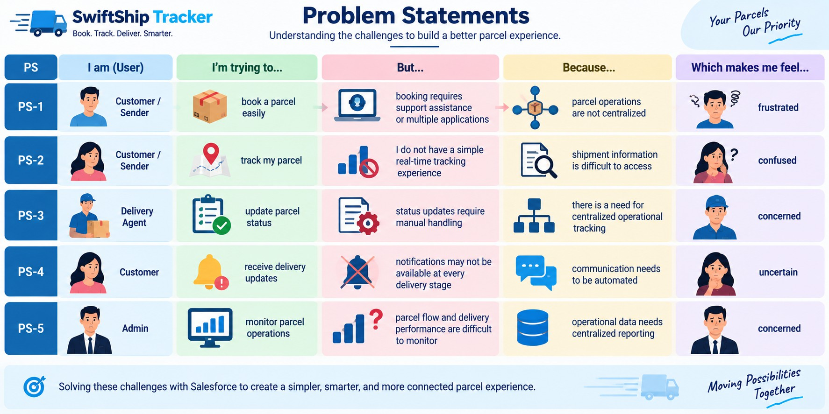

Empathy Map Canvas
User Persona: Customer / Sender
    - Think & Feel: Wants a convenient and simple way to book and track parcels without frequently contacting customer support.
    - Hear: Receives parcel delivery information and shipment status updates from the service provider.
    - See:. Views parcel details, current tracking status, expected delivery date, and other delivery-related information.
    - Say & Do: Books parcels, monitors shipment progress, checks tracking details, and contacts support for delivery updates when needed.
    - Pain: Experiences delivery delays, confusion, limited tracking visibility, and dependence on customer support or multiple applications.

    - Gain: Gets real-time shipment visibility, easy self-service tracking, convenient parcel booking, and timely delivery notifications..
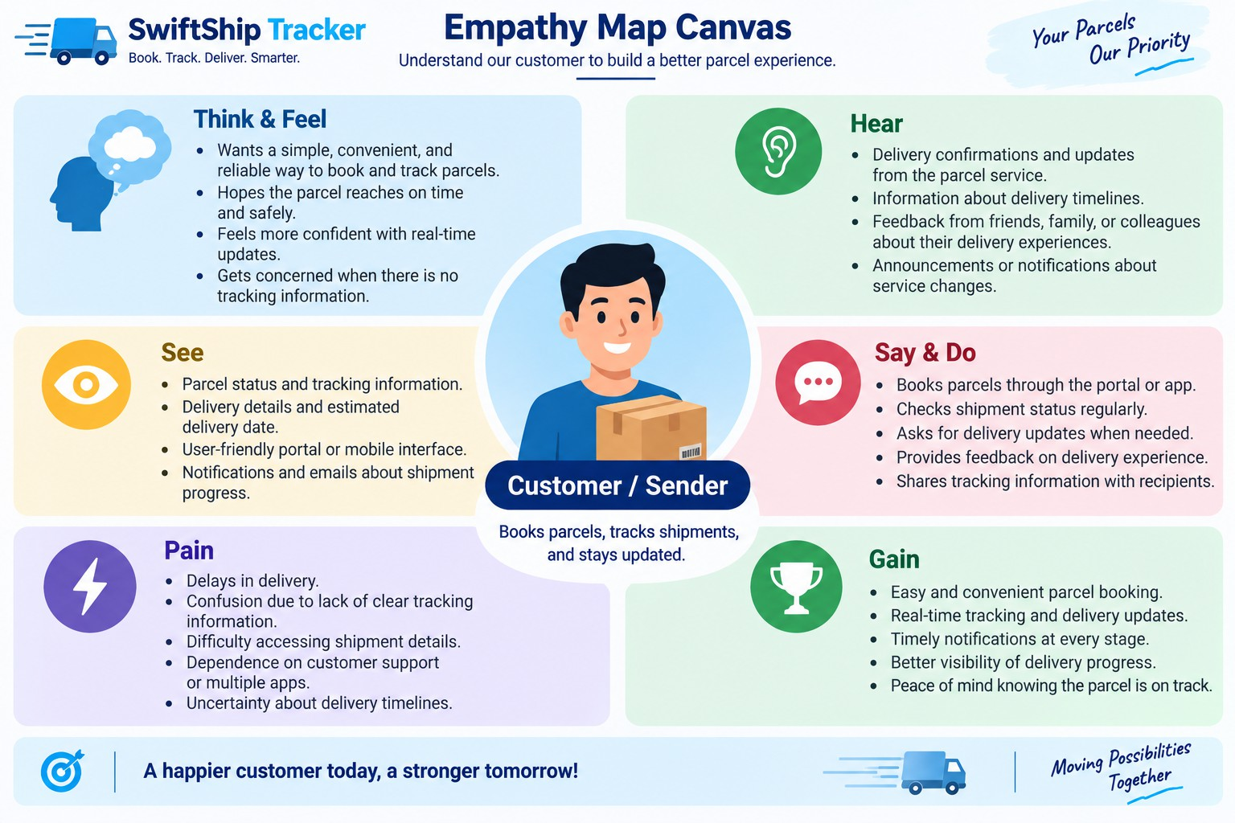

Brainstorming & Idea Prioritization

Ideas Considered
- Manual record-keeping
- Spreadsheet-based parcel tracking
- Dedicated parcel management portal
- Salesforce CRM integrated with Agentforce AI

Final Selection

Salesforce CRM was selected because it provides:

● Centralized parcel and delivery management

● Automated processes using Salesforce Flows

● Real-time shipment tracking and visibility

● Conversational assistance through AI

● Secure, role-based access control

● Comprehensive reports and dashboards
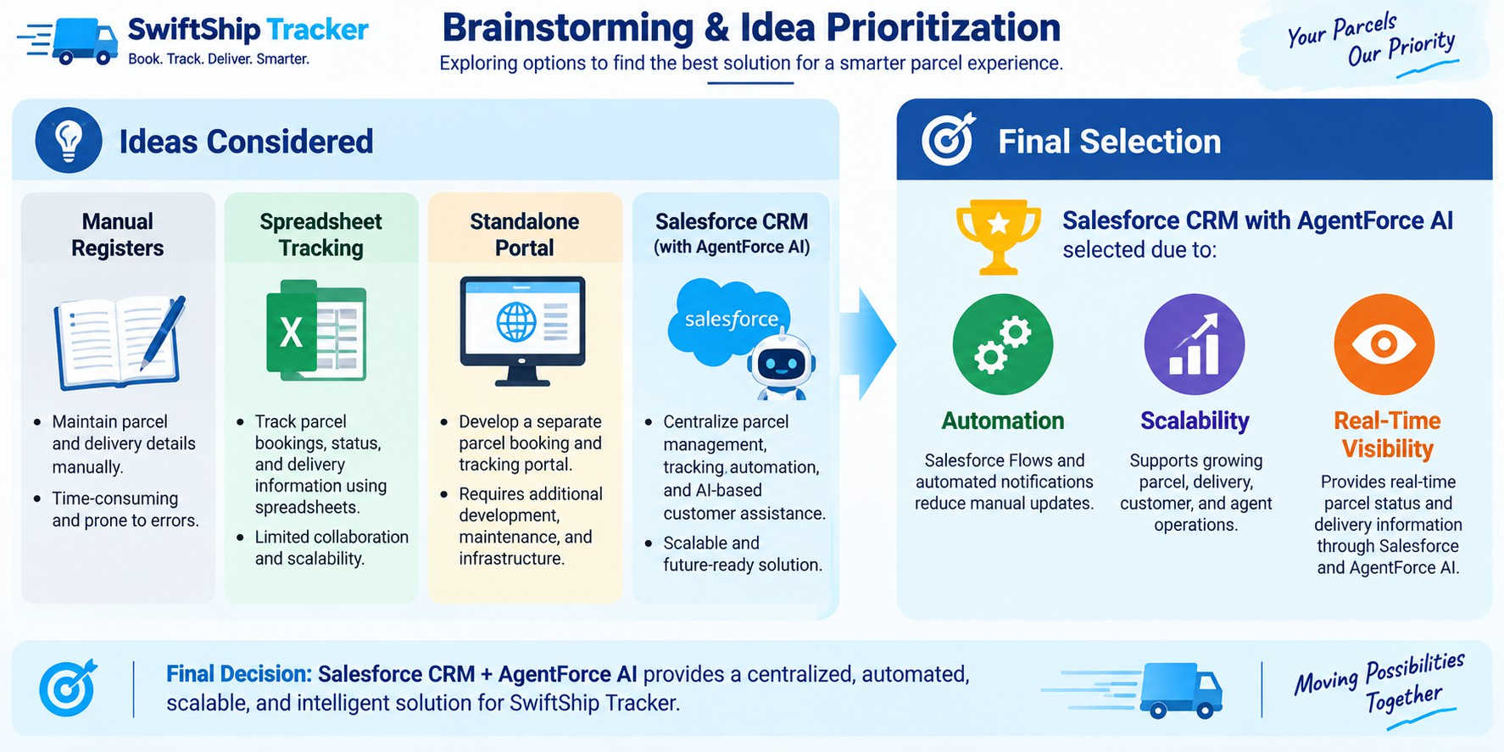

REQUIREMENT ANALYSIS PHASE

Customer Journey Map
Stages:
    - Parcel Booking
    - Parcel Record Creation
    - Dispatch & Shipment
    - In-Transit Tracking
    - Out for Delivery
    - Delivery Confirmation
    - Customer Notification
    - Feedback / Support

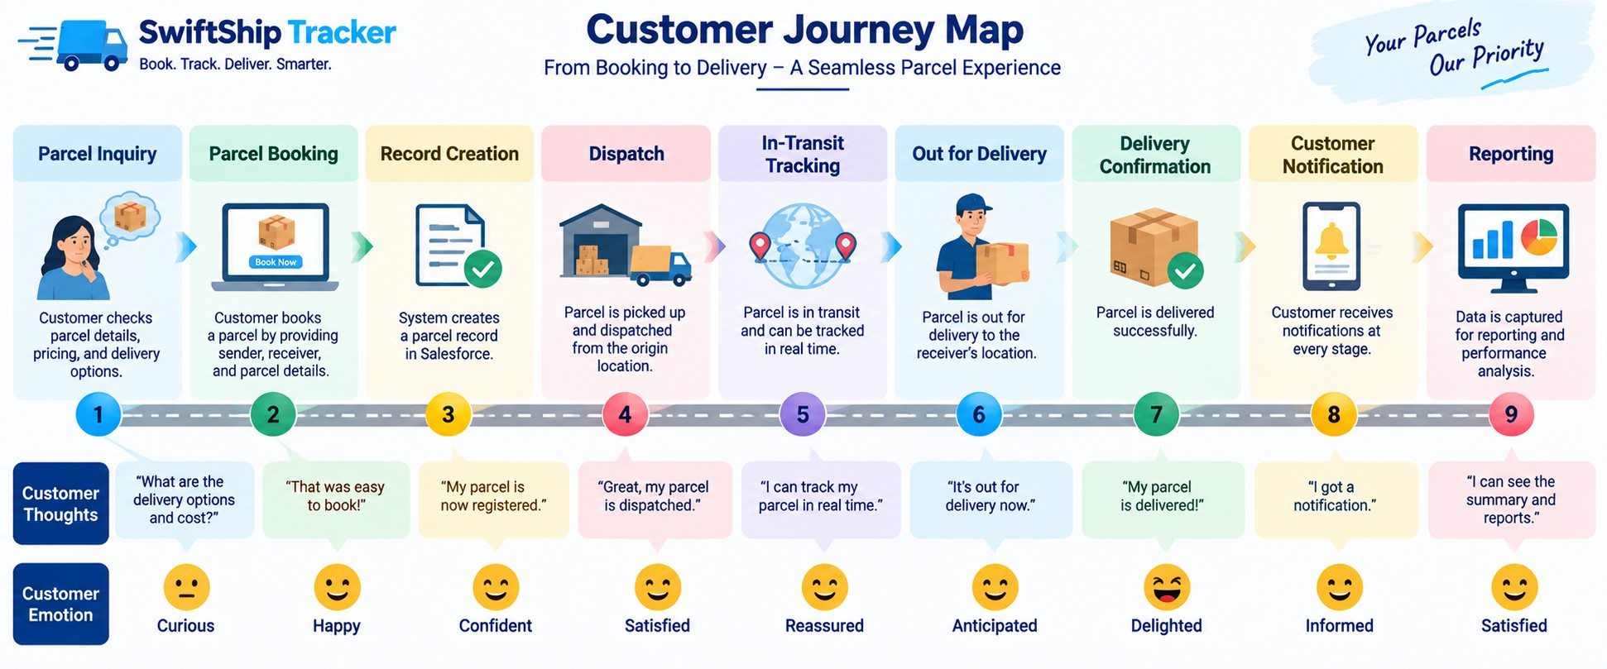

Solution Requirements

Functional Requirements

FR No | Requirement
FR-1 | Create and manage parcel bookings and records
FR-2 | Track the current status of parcels
FR-3 | Record and manage parcel weight details
FR-4 | Manage and maintain the expected delivery date
FR-5 | Store and manage sender details
FR-6 | Store and manage receiver details
FR-7 | Track delivery progress and the parcel’s current location

FR-8 | Allow delivery agents to update parcel status
FR-9 | Send automated notifications and updates to customers
FR-10 | Provide AI-based parcel tracking and assistance
FR-11 | Generate reports and provide operational dashboards
FR-12 | Provide customer access through Experience Cloud

Non-Functional Requirements

NFR | Description
Usability | Provides a simple and user-friendly Salesforce and customer-facing interface
Security | Ensures role-based permissions and field-level access control
Reliability | Maintains accurate parcel status and delivery-related information
Performance | Provides quick and timely responses from Salesforce Flows and Agentforce
Availability | Enables access through Salesforce’s cloud-based platform
Scalability | Supports the expansion of parcel and delivery operations as demand increases.
Data Integrity | Maintains secure, controlled, and relationship-based parcel information
Maintainability | Allows Flows, prompts, topics, and system configurations to be easily modified and updated

Data Flow Diagram
Flow:
Customer / Sender
↓
Parcel Booking
↓
Parcel Record
↓
Sender + Receiver Information

↓
Delivery Record
↓
Parcel Status Update
↓
Current Location & Estimated Delivery
↓
Automated Notifications
↓
Customer Tracking / AgentForce AI
↓
Reports & Dashboards

AI Tracking Flow
Customer Query
↓
AgentForce AI

↓
Prompt Builder – Retrieve Parcel Details
↓
Parcel Record
↓
Status / Weight / Estimated Delivery
↓
Conversational Response

The Prompt Builder implementation retrieves Parcel ID, Status, Weight, and Estimated Delivery Date information for tracking responses.
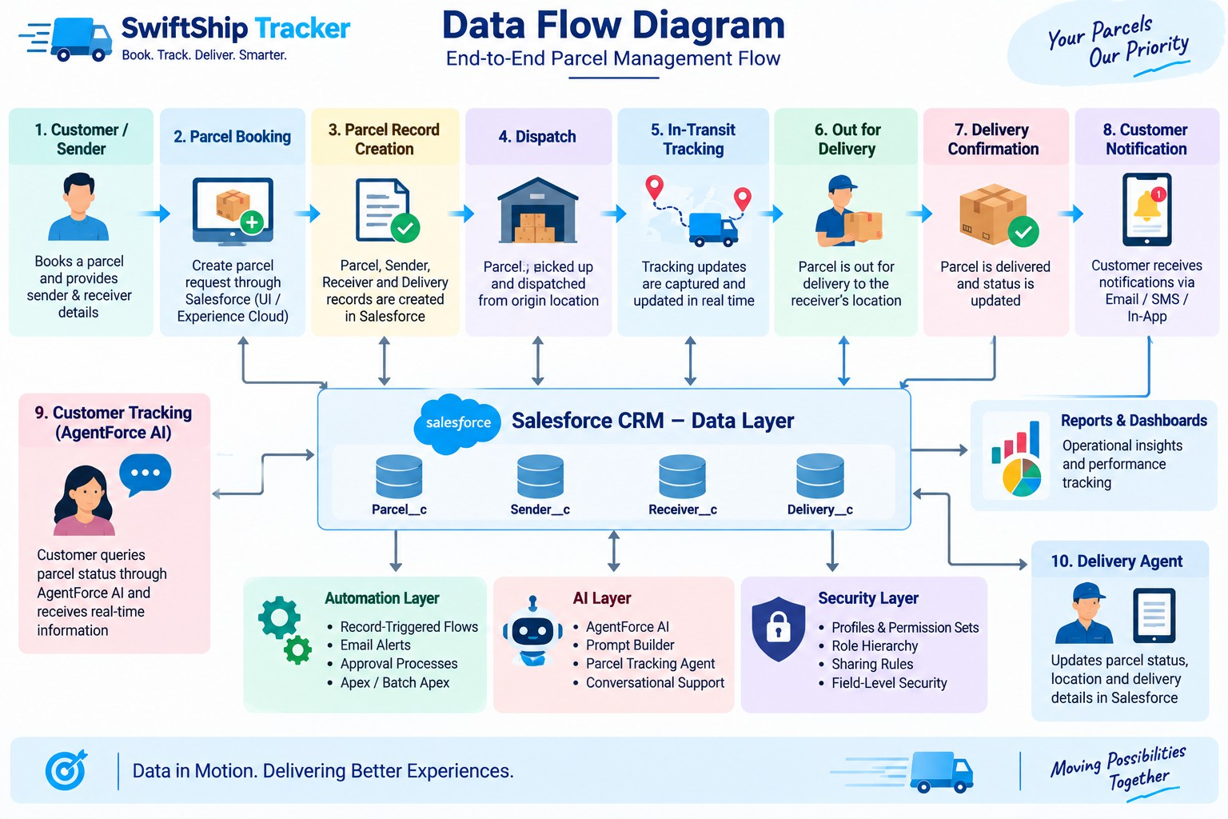

Technology Stack

Layer | Technology
Platform | Salesforce Developer Edition
UI | Lightning App Page, Lightning Record Pages, Experience Cloud
Database | Salesforce Custom & Standard Objects
Business Logic | Salesforce Flows, Apex Classes
Automation | Record-Triggered Flows, Auto-Launched Flows, Scheduled Flows
AI | AgentForce AI, Prompt Builder
Notifications | Email Alerts & Email Templates
Processing | Batch Apex
Security | Profiles, Permission Sets, Role Hierarchy, Field-Level Security, Sharing Rules
Reporting | Reports & Dashboards

PROJECT DESIGN PHASE

Problem–Solution Fit

Problem | Solution | Benefit
Parcel Booking is complicated. | Salesforce Parcel management | Simplified and centralized booking
Parcel tracking depends on support | AgentForce AI with Prompt Builder | Easy Self-service parcel tracking
Parcel Status updates are handled manually. | Salesforce Flows | Automated status management

Gaps in delivery related communication | Automated Email Alerts | Timely customer notifications
Shipment detail are spread across different sources | Parcel, Delivery, Sender & Receiver objects | Organized and structured information
Monitoring parcel operations is challenging | Reports & Dashboards | Improved operational visibility
Different users require different levels of access | Profiles, Roles & Permission Sets | Controlled and secure user access

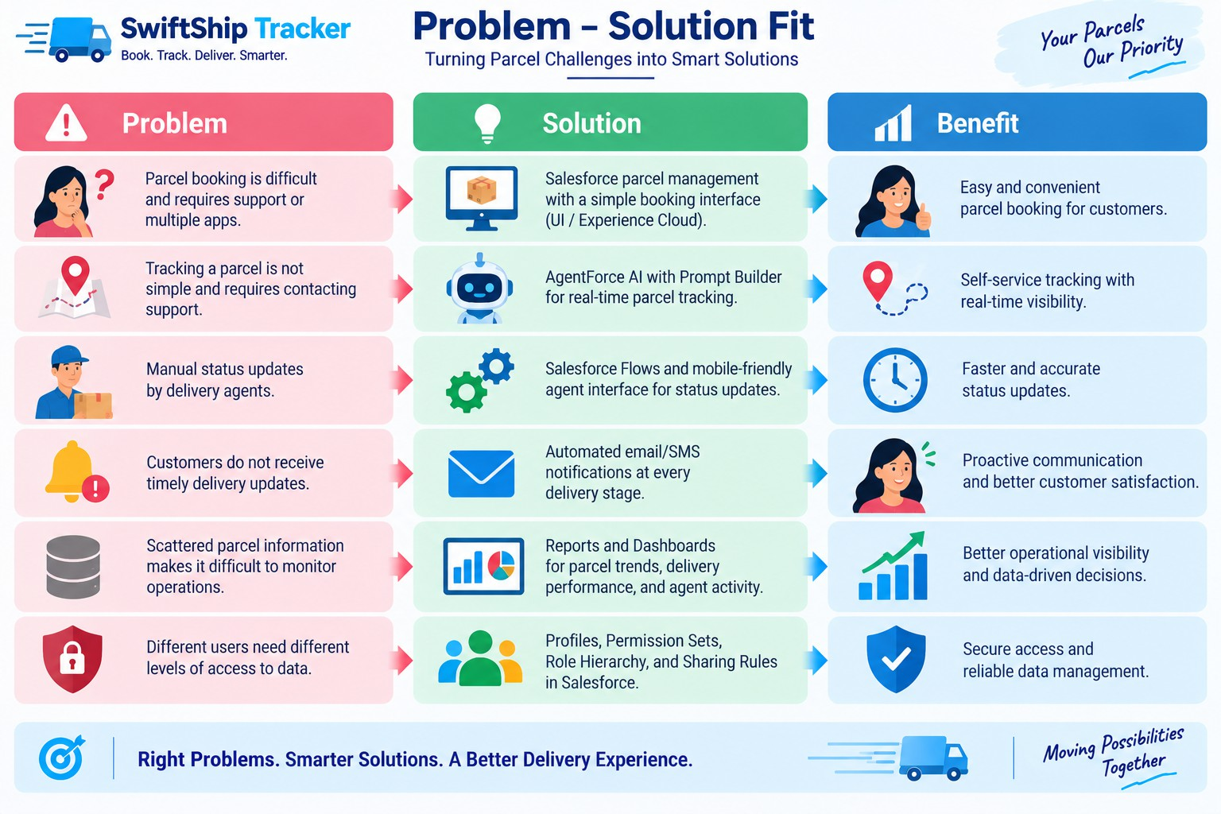

Proposed Solution

Functional Requirements

Parameter | Description
Problem | Parcel booking and tracking are challenging and involve inefficient processes
Solution | A Salesforce-powered Parcel Management System
Innovation | Agentforce AI and Prompt Builder for conversational self-service tracking, along with automated Salesforce Flows
Impact | Agentforce AI and Prompt Builder for conversational self-service tracking, along with automated Salesforce Flows
Business Model | Supports parcel, customer, delivery agent, support team, and administrator activities
Scalability | Accommodates expanding parcel operations through Experience Cloud and integration with external logistics systems

Solution Architecture
    - Users
    - Customer | Delivery Agent | Support Staff | Admin
↓
    - Salesforce Lightning / Experience Cloud
↓
    - SwiftShip Tracker Salesforce Platform
    - Data Layer
      - Parcel
      - Delivery
      - Sender
      - Receiver

    - Automation Layer
      - Flows
      - Approval Processes
      - Apex Classes

      - Batch Apex
      - Email Alerts

AI Layer
  - AgentForce AI
  - Prompt Builder
  - Parcel Tracking Agent
- Security Layer
  - Profiles
  - Roles
  - Permission Sets
  - Sharing Rules
  - Field-Level Security
↓
- Reports & Dashboards
↓
- Parcel Tracking & Operational Insights

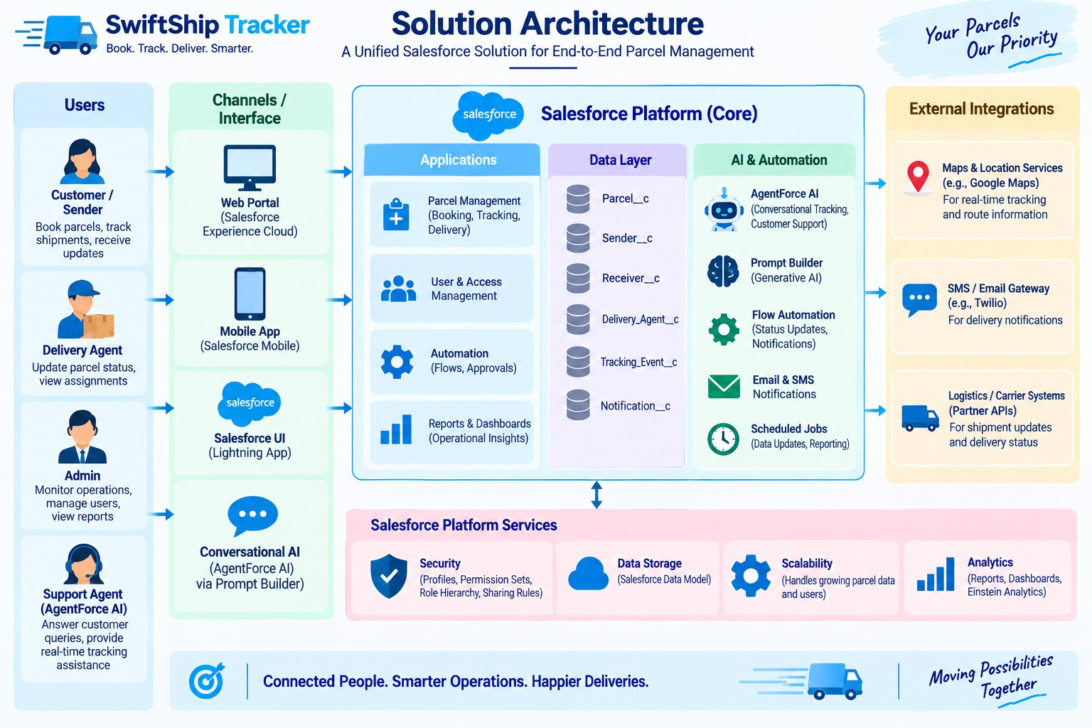

PROJECT PLANNING & SCHEDULING

Project Planning
    - Agile methodology
    - Epics → Stories → Story Points
    - Sprint-based execution
    - Velocity calculation used for estimation

Product Backlog, Sprint Schedule, and Estimation (4 Marks)
Use the below template to create product backlog and sprint schedule

 | Functional Requirement  (Epic) | User Story  Number | User Story / Task | Story Points | Priority | Team Members
Sprint-1 | Developer Setup | USN-1 | As a system administrator, I want to set up and configure the Salesforce environment so that I can develop the SwiftShip Tracker parcel management solution. | 3 | High | Member1
Sprint-2 | Data Modeling | USN-2 | As an admin, I want to create Parcel, Delivery, Sender, and Receiver objects with appropriate relationships so that parcel and delivery information can be stored and managed efficiently. | 5 | High | Member2
Sprint-2 | Data Modeling | USN-3 | As a staff member, I want dedicated tabs and a Lightning App for SwiftShip modules so that I can easily access and manage parcel and delivery activities. | 5 | High | Member3
Sprint-3 | Automation | USN-4 | As a system, I want to validate parcel details, mandatory fields, and booking inputs so that invalid or incomplete parcel records are prevented. | 3 | High | Member4
Sprint-3 | Automation | USN-5 | As a delivery coordinator, I want automated Flows to update parcel status and delivery information so that manual processing is minimized. | 3 | High | Member4
Sprint-4 | Apex | USN-6 | As a system, I want Apex triggers and classes to automatically handle important parcel and delivery operations so that critical processes are completed accurately. | 5 | High | Member1
Sprint-4 | Apex | USN-7 | As an inventory or operations manager, I want Batch Apex jobs to automatically process and update parcel and delivery records so that operational information remains current and accurate. | 5 | High | Member2
Sprint-5 | Reports | USN-8 | As a manager, I want reports displaying parcel status, delivery performance, and operational metrics so that I can monitor SwiftShip activities and support informed decision-making. | 4 | High | Member3
Sprint-6 | Dashboards & AI | USN-9 | As a manager, I want dashboards displaying parcel status, delivery performance, and key metrics, while Agentforce provides AI-based tracking assistance, so that I can monitor operations effectively.. | 4 | Medium | Member4

Sprint | Total Story Points | Duration | Sprint Start Date | Sprint End Date (Planned) | Story Points Completed (as on Planned End  Date) | Sprint Release Date (Actual)
Sprint-1 | 20 | 1 Day | 28 Sep 2026 | 28 Sep 2026 | 20 | 28 Sep 2026
Sprint-2 | 20 | 1 Day | 29 Sep 2026 | 29 Sep 2026
Sprint-3 | 20 | 1 Day | 30 Sep 2026 | 30 Oct 2026
Sprint-4 | 20 | 2 Days | 30 Sep 2026 | 01 Oct 2026
Sprint-5 | 20 | 2 Days | 30 Sep 2026 | 01 Oct 2026
Sprint-6 | 20 | 1 Day | 01 Oct 2026 | 01 Oct 2026

Project Tracker, Velocity & Burndown Chart:

Project Developmet Phase:

Phase 1: Requirement Analysis & Planning
Objective:

“Customers may experience delays and confusion when booking, tracking, and managing parcel deliveries because they often need to contact support or switch between multiple applications. A conversational AI agent can simplify this process by enabling parcel booking, live tracking, and delivery management through a single platform.”
Key Requirements:

- Collect requirements from customers, end users, and delivery agents.
- Define the system scope and identify user personas such as Customer, Agent, and Admin.
- Design a data model that establishes relationships between Parcel, Sender, Receiver, and Delivery.
- Identify important use cases, including parcel booking, shipment tracking, and automated delivery updates.
- Select suitable Salesforce technologies, including Salesforce Flows, Prompt Builder, and Agentforce AI.

Defining Project Scope & Objectives

Project Scope:
  - Build a scalable CRM solution for parcel delivery organizations to efficiently manage customer bookings, shipments, and delivery activities.
  - Manage the complete parcel lifecycle, beginning with booking and continuing through dispatch, tracking, and delivery confirmation.
  - Implement a comprehensive data model along with automation using Flows, Apex, and Email Alerts, supported by Prompt Builder and reporting dashboards.
  - Provide role-based access for administrators, delivery agents, and customers using Salesforce Profiles, Permission Sets, and Experience Cloud.
  - Provide customers with real-time parcel visibility while enabling agents to perform simplified operational tracking through conversational AI support.

Objectives Summary:

- Automate parcel booking, tracking, and delivery notifications to streamline operations and minimize manual updates.
- Improve customer experience by providing transparent, real-time shipment information and self-service tracking.
- Increase agent productivity through centralized dashboards and guided Flows for efficient status updates.
- Provide useful business insights through reports and dashboards covering parcel trends, delivery performance, and agent activities.
- Maintain security and reliability through Salesforce role hierarchies, sharing rules, and controlled data access.

Gathering & Analysing User Needs

Users Involved:

- Customers / Senders – Users who create parcel bookings, track shipments, and receive real-time delivery updates through the portal or AI agent.
- Delivery Agents – Handle assigned parcels, update shipment statuses, and ensure parcels are delivered to customers on time.
- Customer Support Team – Manage delivery-related concerns, answer customer questions, and maintain effective communication.
- Admin Team – Configure the Salesforce environment, manage users and security settings, and monitor operational activities.
- System Integrator / Developer – Develop and configure automation, AI agents, and backend integrations.

Key Functional Needs:

- Provide customers with a smooth parcel booking and tracking experience through Salesforce Experience Cloud or AI-assisted interactions.
- Enable delivery agents to update parcel statuses in real time, such as Booked → In Transit → Out for Delivery → Delivered.
- Automatically send email notifications to customers whenever the parcel reaches a new delivery stage.
- Manage sender and receiver information, including addresses, contact numbers, and email addresses for communication.
- Integrate an AI Agent through Prompt Builder to respond to parcel status queries and provide automated assistance.
- Provide reports and dashboards for administrators to monitor parcel movement, delivery performance, and agent activities.
- Apply role-based security using Profiles and Permission Sets to control access according to user responsibilities.

Tools Used:

- Salesforce Developer Org – For configuration, development, and testing.
- Prompt Builder (AgentForce AI) – To create intelligent parcel tracking prompts and responses.
- Salesforce Flow Builder – To automate booking, tracking, and delivery updates.
- Google Sheets / Docs – For initial data planning, requirement documentation, and system mapping.

Identifying Key Salesforce Features & Tools Required

Salesforce Features Planned:
- Custom Objects:
Parcel c, Delivery c, Sender c, Receiver c
- Standard Objects:
Account, Contact, Case, Task, EmailMessage, User
- Automations: Record-Triggered Flows, Auto-Launched Flows, Approval Processes, and Scheduled Flows
- Apex: Apex Classes for automated parcel operations, such as Lead-to-Parcel mapping and delivery notifications, along with Batch Apex for scheduled updates and notifications.
- UI: Lightning App Page (SwiftShip Tracker App), Dynamic Forms for Parcel Details, Lightning Record Pages, and Experience Cloud for Customer Access
- AgentForce AI & Prompt Builder: Integrated AI agent trained to fetch parcel data based on Parcel ID and respond to tracking or delivery status queries
- Email Services: Custom Email Alerts and Templates for booking confirmations, delivery updates, and completion acknowledgments

- Security: Profiles, Permission Sets, Role Hierarchies, Field-Level Security, and Sharing Rules to ensure controlled access for Admin, Agent, and Customer roles

Designing Data Model and Security Model
Data Model Includes:
  - Parcel c (Custom Object)
  - Stores core parcel details such as Parcel ID, Status, Weight, and Estimated Delivery Date.
  - Linked to Sender c and Receiver c objects to fetch sender and receiver details.
  - Connected with Delivery c object to track real-time parcel location and status.
  - Delivery c (Custom Object)
  - Stores delivery-specific information such as current location, estimated delivery date, and linked parcel.
  - Connected with Sender c and Parcel c for relationship-based tracking.
  - Used by agents to update and monitor delivery status during the parcel lifecycle.
  - Sender c (Custom Object)
  - Captures sender-related information such as address, contact number, and email.
  - Linked to multiple parcels to track sender history and associated deliveries.
  - Used for sending booking confirmations and delivery updates via automated emails.
  - Receiver c (Custom Object)
  - Stores receiver details such as address, contact, and email for communication and delivery confirmation.
  - Linked to Sender c and Parcel c to associate both ends of the shipment process.
  - Used by agents for delivery reference and automated email notifications upon completion.

Security Model Design:

- Role Hierarchy:
Administrator → Delivery Manager → Agent → Customer
- Profiles:
Admin Profile: Full access to all objects and records.
Delivery Agent Profile: Read/Edit access to Parcel, Delivery, Sender, and Receiver objects.
Customer Profile: Read-only access to their own parcel details via Experience Cloud. Support
Staff Profile: Access to Cases and Parcel details for issue resolution.
- Permission Sets:
Used to grant additional privileges (e.g., “Update Delivery Status,” “Access Agent Console”).

- Record-Level Security:
Sharing Rules applied for Parcel c and Delivery c to allow controlled access for agents and managers.
Customers can only view records linked to their own Sender or Receiver details.
- Field-Level Security:
Sensitive fields like Sender Email, Receiver Contact, and Location Coordinates restricted to Admin and Agent profiles only.

Phase 2: Salesforce Development –Backend & Configurations
This phase involved developing the main backend functionality of the SwiftShip Tracker system. Custom objects were created for Parcel, Sender, Receiver, and Delivery, along with the required relationships between them. Salesforce Flows were implemented to automate parcel status updates, while approval processes were configured to support controlled operations.

Milestone 1- Salesforce Account
Introduction:
If you are new to Salesforce and are unsure about what it is, how it works, or where to begin your learning journey, this section provides a basic introduction. It explains the Salesforce platform and its key capabilities to help users understand its purpose and functionality.
What Is Salesforce?
Salesforce is a cloud-based customer success platform that provides tools for managing sales, customer service, marketing, data analysis, and customer engagement. It helps organizations connect with customers, improve productivity, and manage customer-related operations efficiently.

Creating Developer Account
Creating a developer org in salesforce.

- Go to https://developer.salesforce.com/signup
- On the sign-up form, enter the following details:

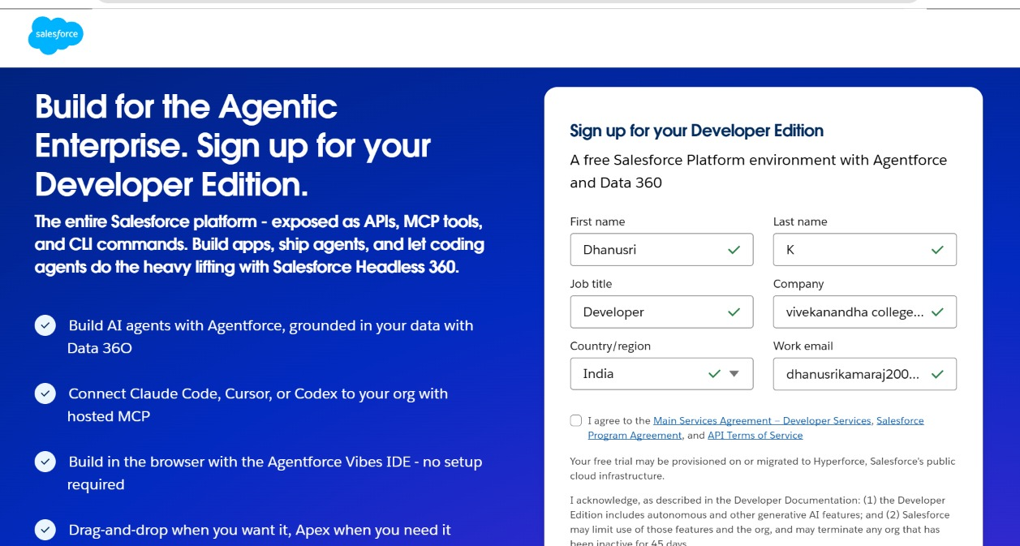

  - First name & Last name
  - Email
  - Job Title: Developer
  - Company: College Name
  - Country: India

Click on sign me up after filling these

- Go to the inbox of the email that you used while signing up. Click on the verify account to activate your account. The email may take 10-30mins and sometimes 2 hours.
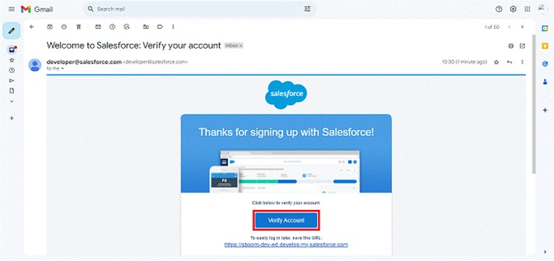

- Click on Verify Account
- Give a password and answer a security question and click on change password.
- Then you will redirect to your salesforce setup page.
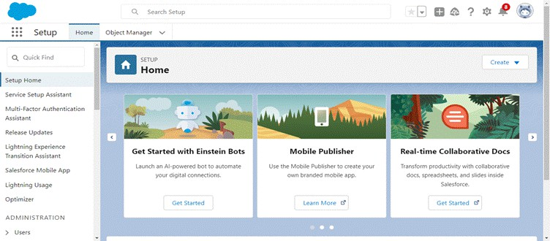

Milestone 2- Objects Creation

To create an object:
- From the setup page
- Click on Object Manager
- Click on Create >> Click on Custom Object.
- Enter the label name as Parcel
- Enter Plural label name as Parcels
- Enter Record Name as Parcel Name
- Select Data Type as Text: Parcel Name
- Select Allow reports.
- Select Allow search.
- Allow Track Field History
- Click on Save and New
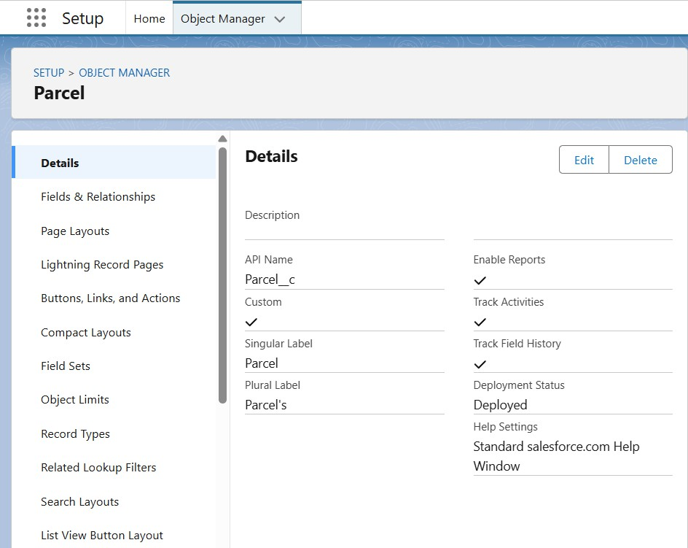

Creating Delivery Object
To create an object:

- From the setup page
- Click on Object Manager
- Click on Create >> Click on Custom Object.
- Enter the label name as Delivery
- Enter Plural label name as Deliveries
- Enter Record Name as DeliveryName
- Select Data Type as Text: DeliveryName
- Select Allow reports.
- Select Allow search.
- Allow Track Field History
- Click on Save and New
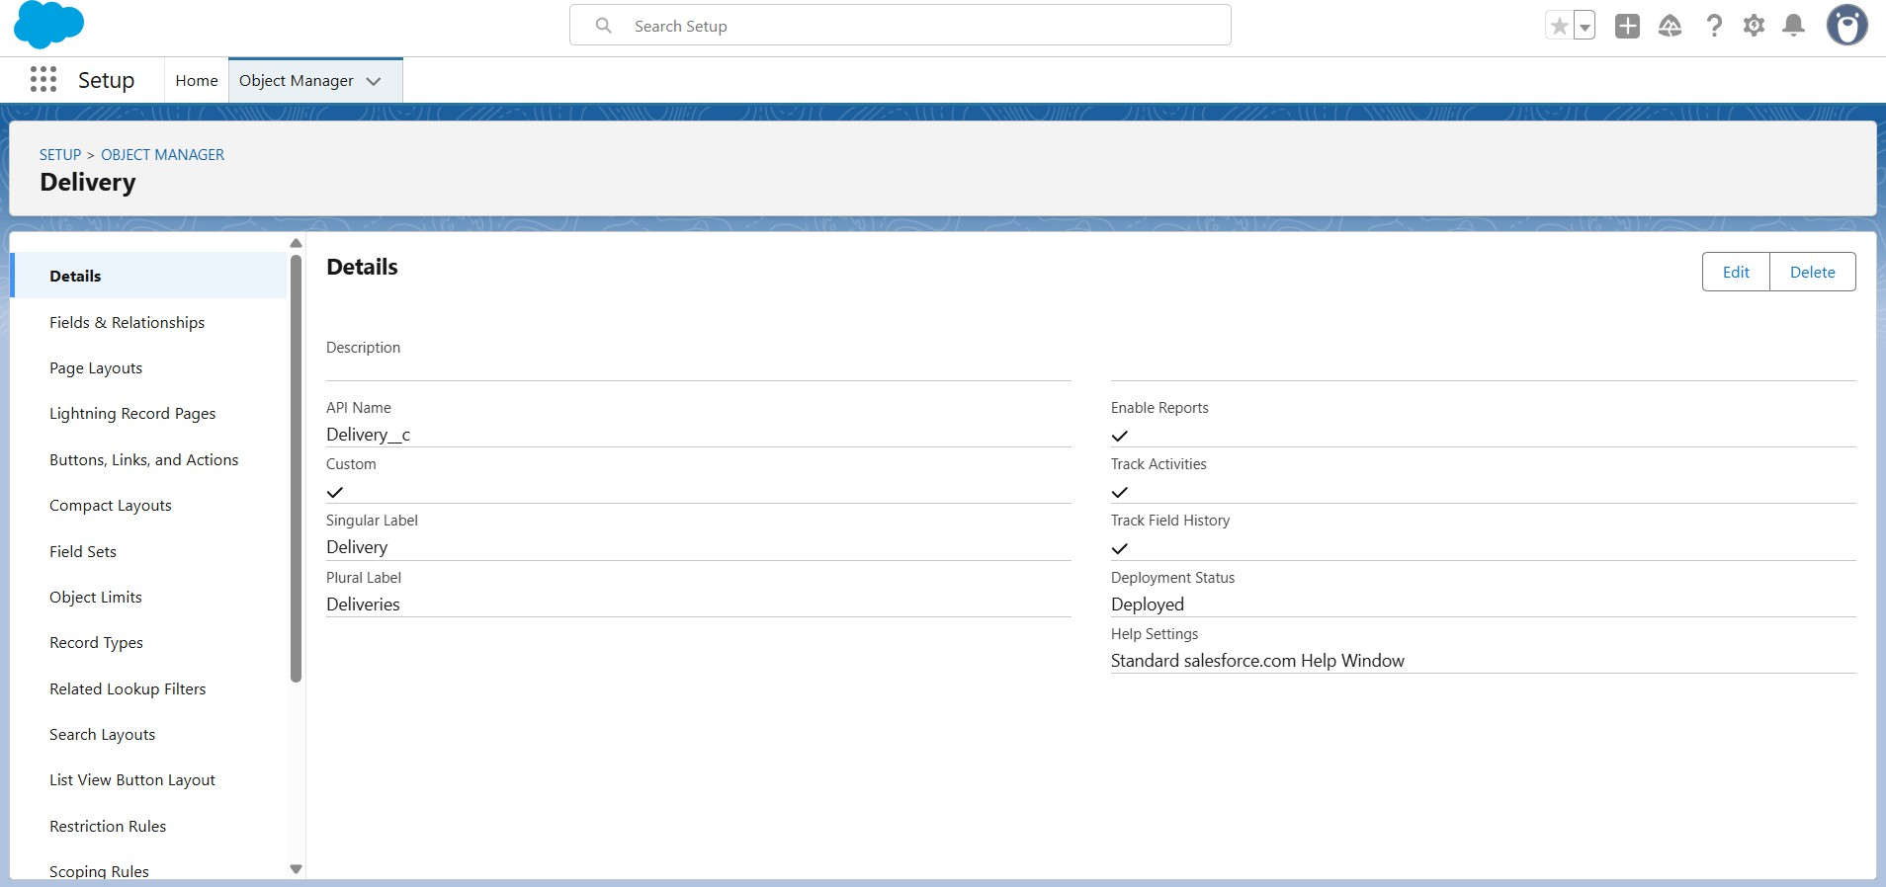

Creating Sender Object
To create an object:

- From the setup page
- Click on Object Manager
- Click on Create >> Click on Custom Object.
- Enter the label name as Sender
- Enter Plural label name as Sender's
- Enter Record Name as SenderName
- Select Data Type as Text: SenderName
- Select Allow reports.
- Select Allow search.
- Allow Track Field History
- Click on Save and New

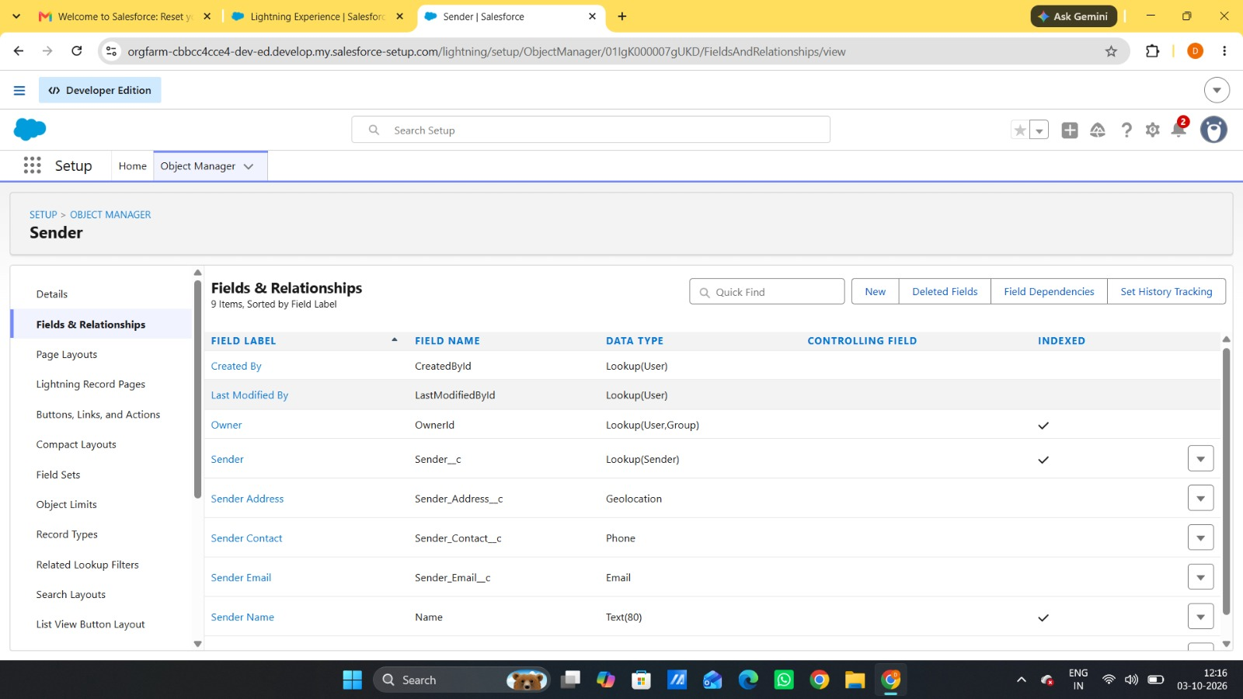

Creating Receiver Object

To create an object:

- From the setup page
- Click on Object Manager
- Click on Create >> Click on Custom Object.
- Enter the label name as Receiver
- Enter Plural label name as Receiver's
- Enter Record Name as ReceiverName
- Select Data Type as Text: ReceiverName
- Select Allow reports.
- Select Allow search.
- Allow Track Field History
- Click on Save and New

Milestone 3 - Tabs

Creating a tab for Parcel Object

- Go to Setup and enter Tabs in the Quick Find search bar.
- Select Tabs from the search results.
- Under Custom Object Tabs, click New.
- Select the Parcel object and choose an appropriate Tab Style.
- Click Next. On the Add to Profiles page, leave the settings as default and click Next. On the Add to Custom Apps page, clear the Include Tab option.
- Ensure that Append the tab to the users' existing personal customizations is selected.
Click Save to create the Parcel tab.
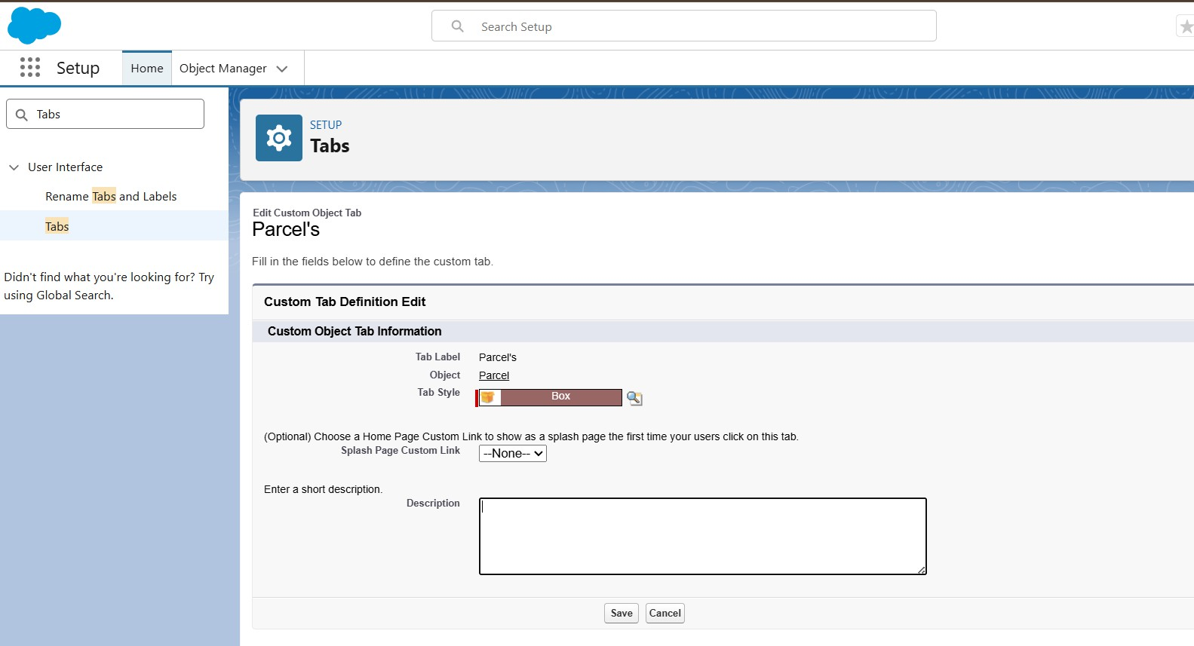

More Tab Creation
- Navigate to Setup and search for Tabs using the Quick Find box.
- Select Tabs from the User Interface section.
- In the Custom Object Tabs section, click New.
- Choose the required object (Delivery, Sender, or Receiver) and select a suitable Tab Style.
- Click Next, keep the Add to Profiles options unchanged, and then click Next again.
- On the Add to Custom Apps page, clear the Include Tab checkbox.
- Make sure Append tab to the user’s existing personal customizations remains selected.
- Click Save. Repeat the same procedure for the remaining objects: Delivery, Sender, and Receiver.
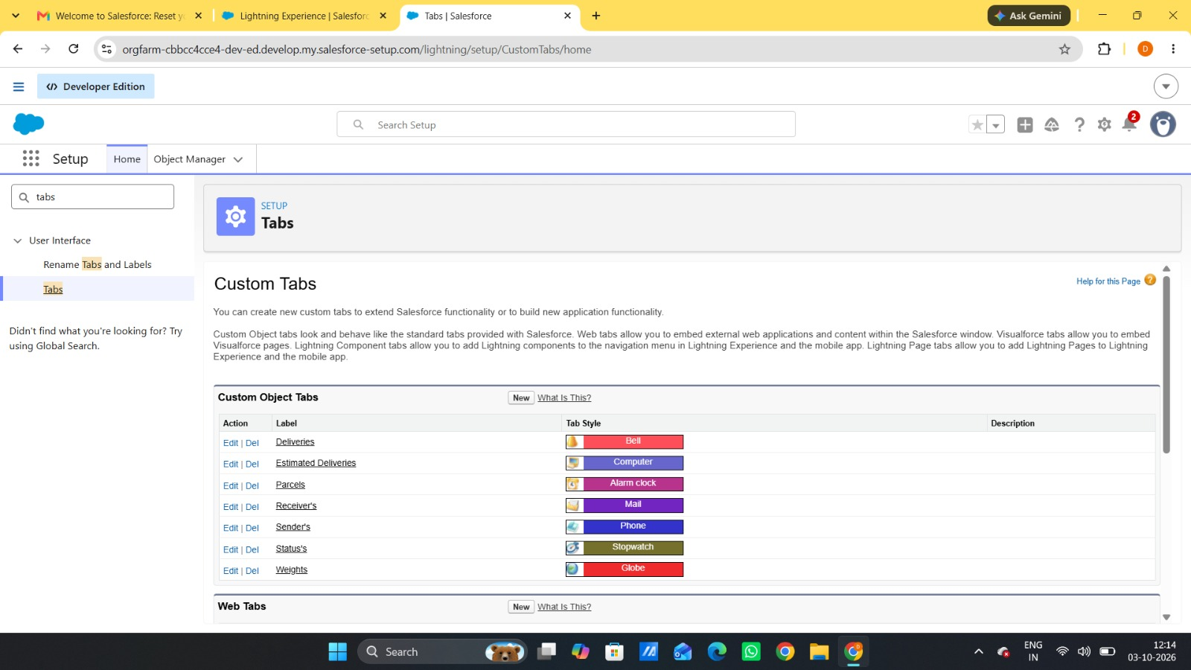

Milestone 4 – Fields & Relationships
Create the required fields and relationships for the custom objects that were created in the previous milestone.
Creating Fields and Relationships for the Parcel Object
- Open Object Manager from the Setup page, next to the Quick Find box.
- Search for and select the Parcel custom object.
Field 1: Parcel ID
● Navigate to Fields & Relationships and click New.
● Select Auto Number as the data type.
● Set the display format to P-{000}.

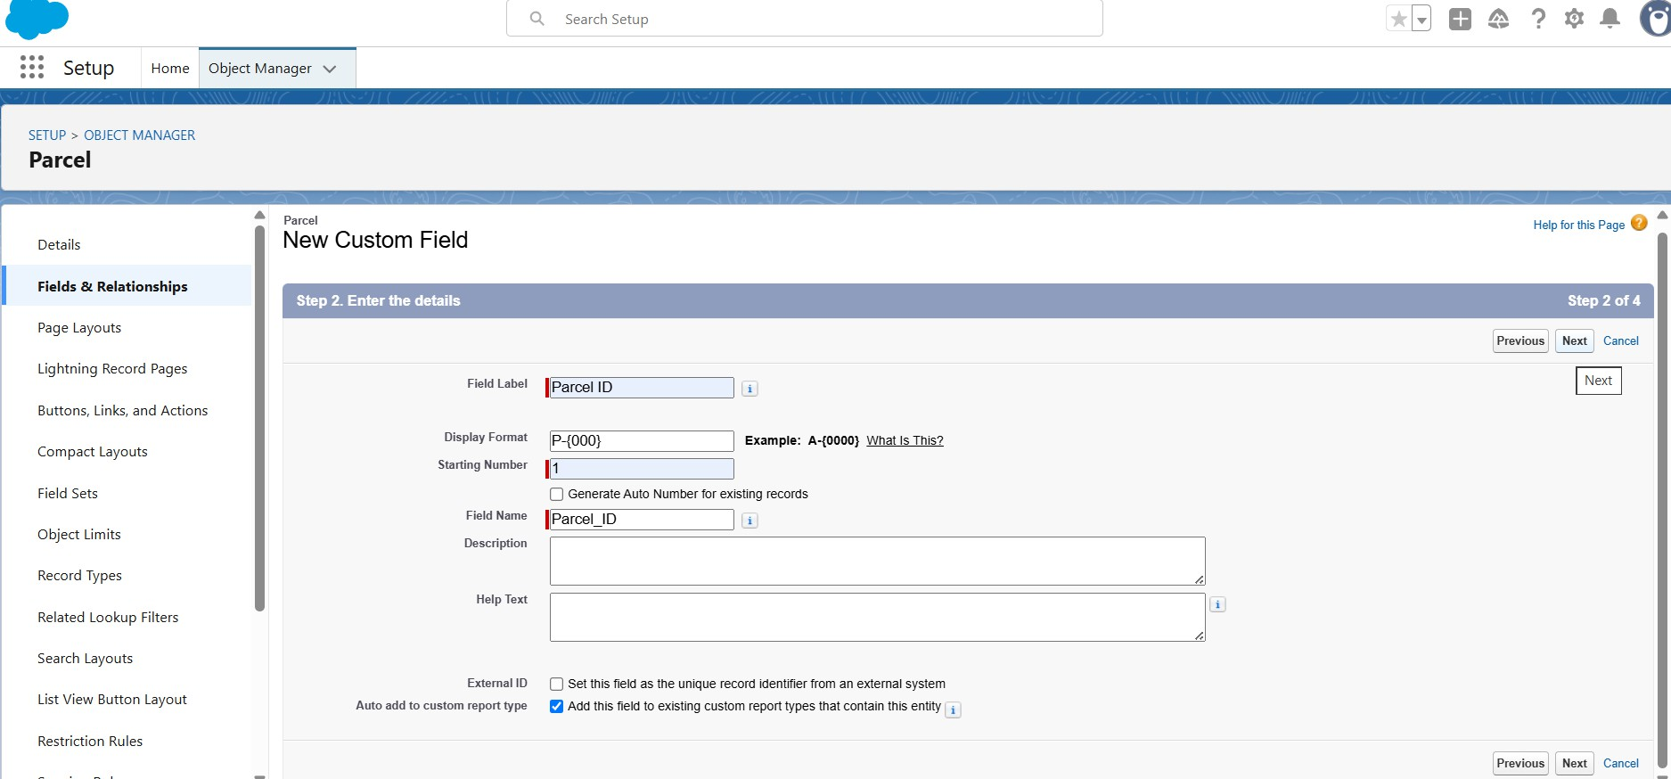

● Click Next, then click Next again, and select Save & New.
- Repeat Steps 1 and 2 to create the remaining fields for the Parcel object, such as Status, Weight, Estimated Delivery, and Sender, as specified in the table below.
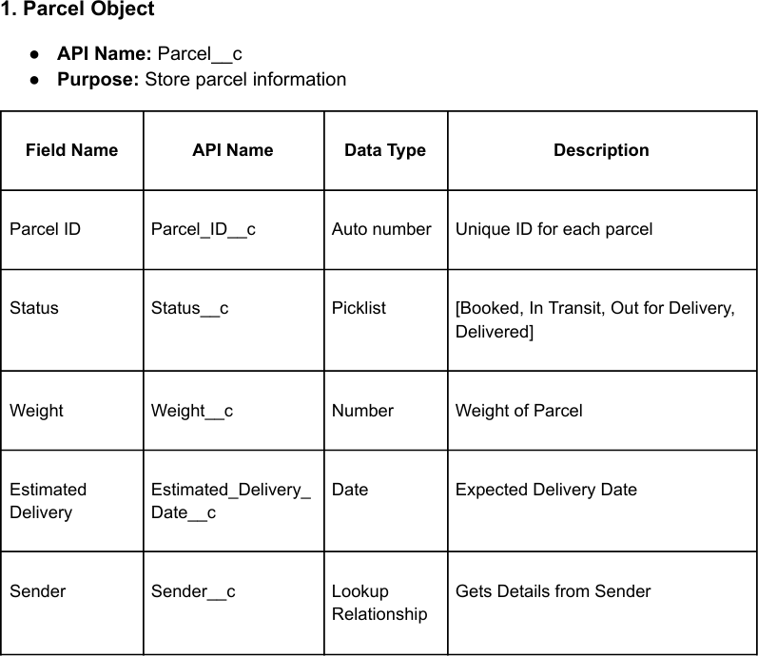

Creating Fields And Relationships For Delivery Object
Beside the Quick Find box you have, Object Manager click on it.
- Search for and select your Delivery object.
Field 1: Current Location
  - Go to Fields & Relationships → click New
- Choose Data Type: Geolocation → click Next. Field Label: Current Location
Click Next → Next → Save & New.
- Follow step 1 and 2 to create the remaining fields(Estimated Delivery, Sender, Parcel) of the Delivery object mentioned in the table below.
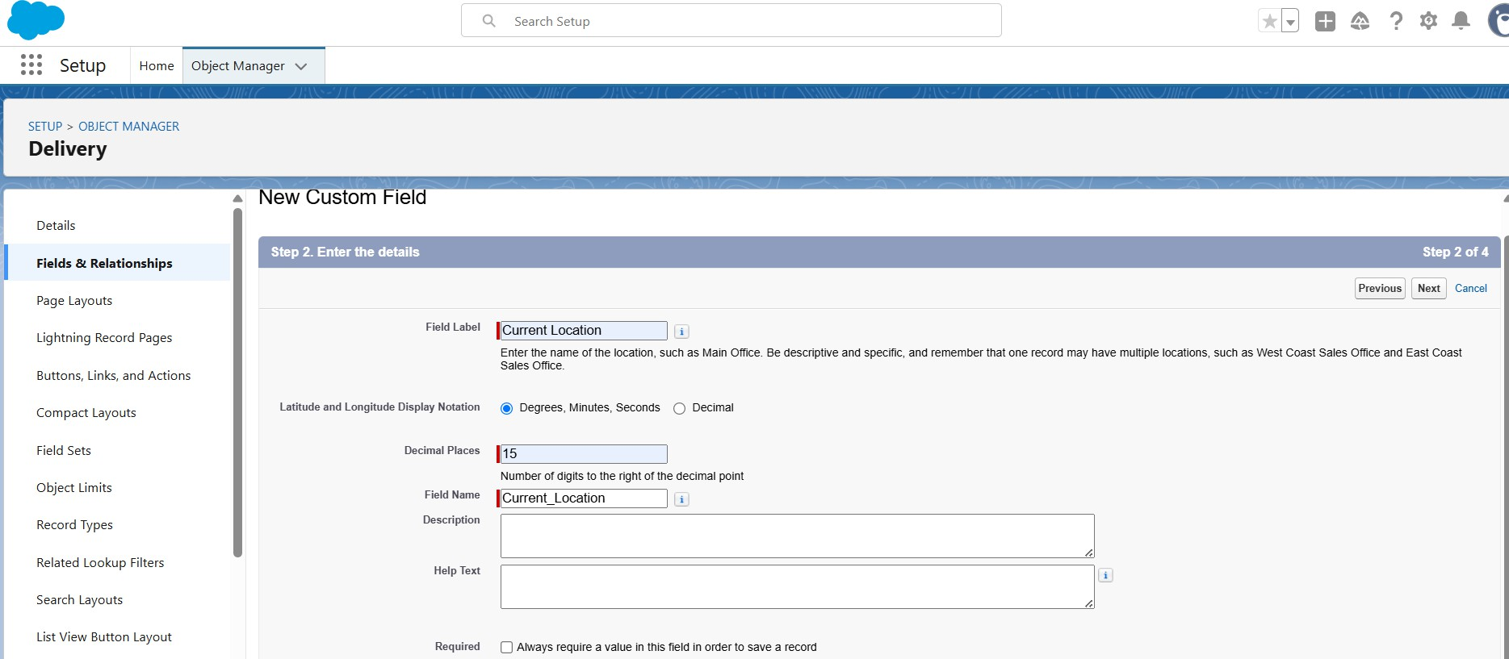

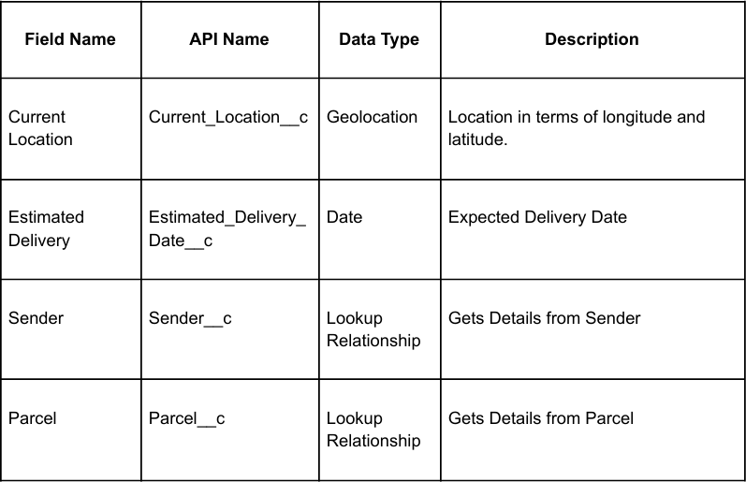

Creating Fields And Relationships For Sender Object
Beside the Quick Find box you have, Object Manager click on it.
- Search for and select your Sender object.
Field 1: Sender Address
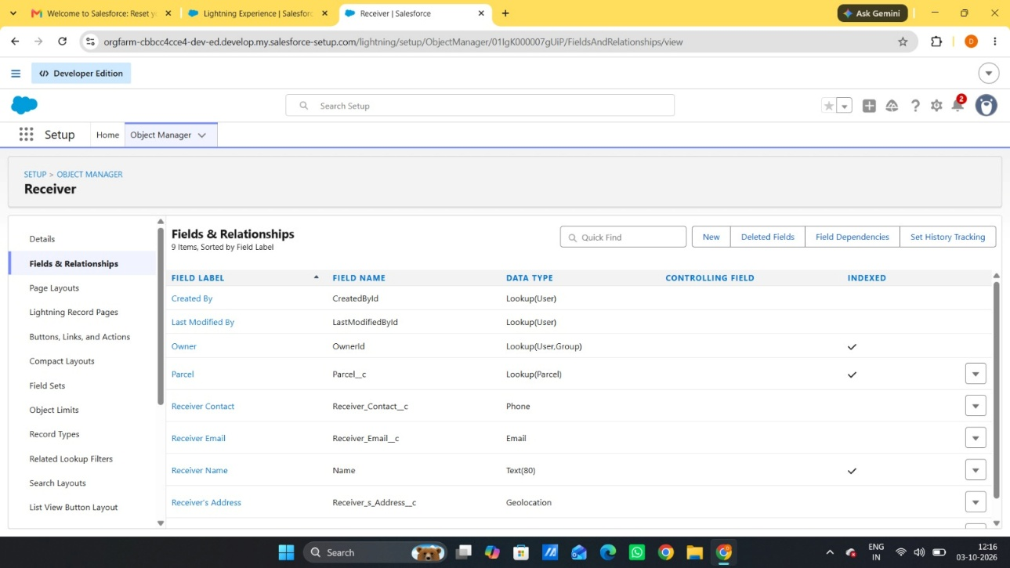
- Go to Fields & Relationships → click New

  - Choose Data Type: Geolocation → click Next. Field Label: Sender Address
Click Next → Next → Save & New.
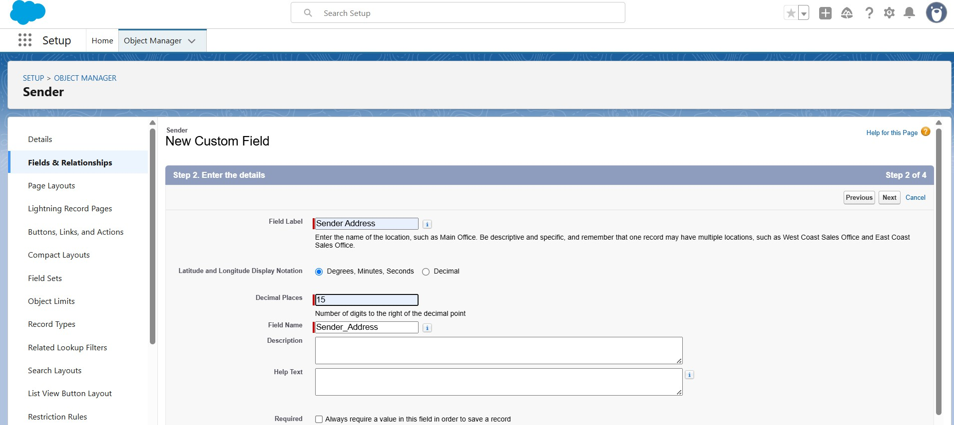

3. Follow step 1 and 2 to create the remaining fields (Sender Contact, Sender Email) of the Sender object mentioned in the table below.

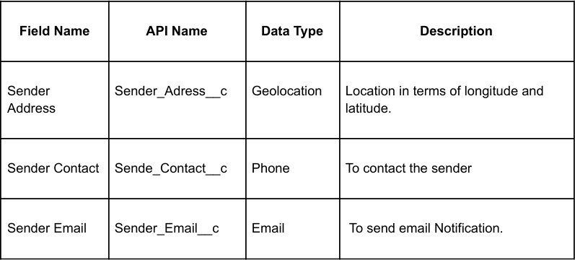

Creating Fields And Relationships For Receiver Object
Beside the Quick Find box you have, Object Manager click on it.
- Search for and select your Receiver object.
Field 1: Receiver Address
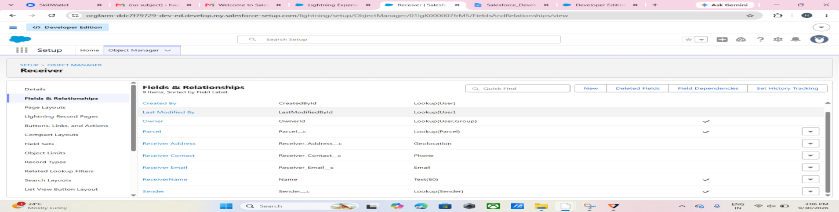
  - Go to Fields & Relationships → click New
  - Choose Data Type: Geolocation → click Next. Field Label: Receiver's Address
Click Next → Next → Save & New.
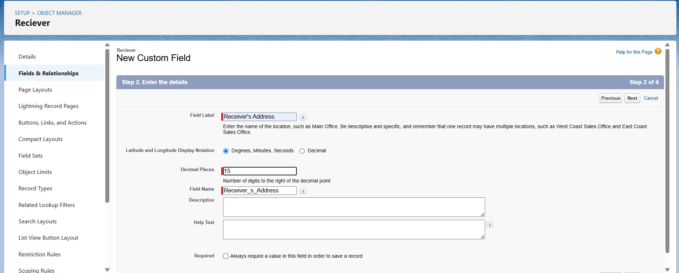
  - 3. Follow step 1 and 2 to create the remaining fields (Receiver Contact, Receiver Email, Sender, Parcel) of the Receiver object mentioned in the table below.

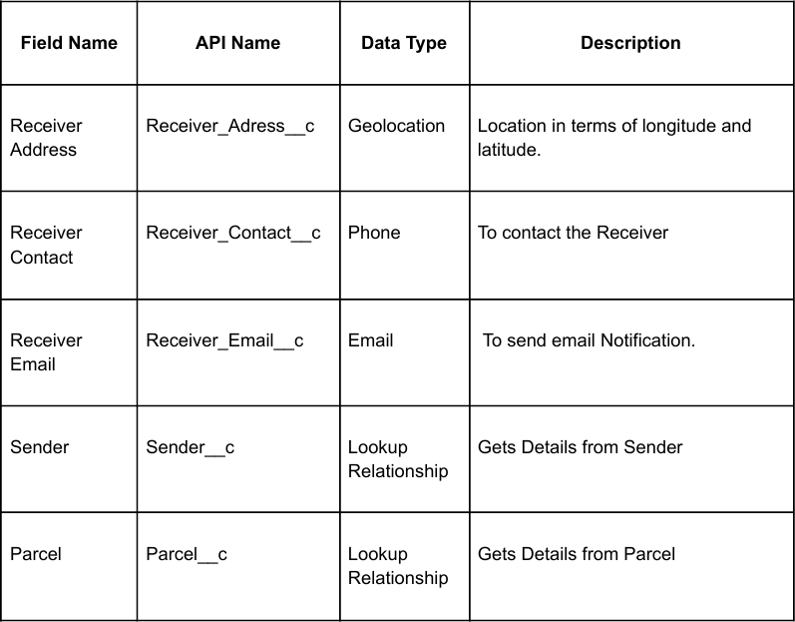

Milestone 5 – Prompt Builder
Designing Prompts for Agent Building
Prompt Builder in Salesforce is used to create and manage prompts that support AI-powered agent functionality.
- In Salesforce, open Setup.
- In the Quick Find box, search for Prompt Templates. Alternatively, open Agent Builder and navigate to Prompt Templates.
- Click New Prompt Template and select Record Summary Template.
- Enter the details
  - Label: Retrieve Parcel Details
  - API Name: Retrieve_Parcel_Details
  - Description: Retrieves parcel details where Parcel_ID matches the user input.
- Enter the Prompt Template Content
In the Prompt Template Text area, paste the following exactly:
Retrieve details from Parcelc where Parcel_ID c matches user input. Return response in this format:

Parcel Tracking Update
-Parcel Name:{!$Input:Parcel c.Name}
- Parcel ID:{!$Input:Parcel c.Parcel_ID c}
- Status:{!$Input:Parcel c.Status c}
- Weight:{!$Input:Parcel c.Weight c}
- Estimated Delivery Date:{!$Input:Parcel c.Estimated_Delivery_Date c}
- Add Resource Mapping
- Scroll down to the Resources / Insert Resources section.
  - Click Insert Resource → choose Object.
  - Select Parcel c.
  - Add the following fields:
  - Name
  - Parcel_ID c
  - Status c
  - Weight c
  - Estimated_Delivery_Date c
- Click Insert Resource (or Add) for each one.
- Click Save.
- Then click Activate to make this Prompt Template available for your agent or flow.

Testing the Prompt
Test the Prompt:
- Open your Agent preview.
- Type: “Track parcel P-12345”.
- It should return details from the Parcel record.
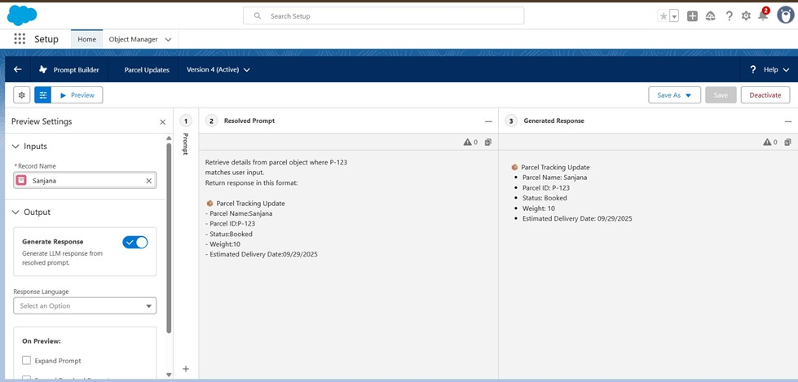

Milestone 6 - Flows

Create flows for capturing the response as shown.
Go to Setup → search Flows → click New Flow.
- Choose Auto-Launched Flow (No Trigger) → click Create
- Add Input Variables (to allow Agent to pass values):
  - Click On New Recourse →Variable → Available for Input.
  - Ids → Data Type: Text → Available for Input.
  - Output → Data Type: Text → Available for Output.

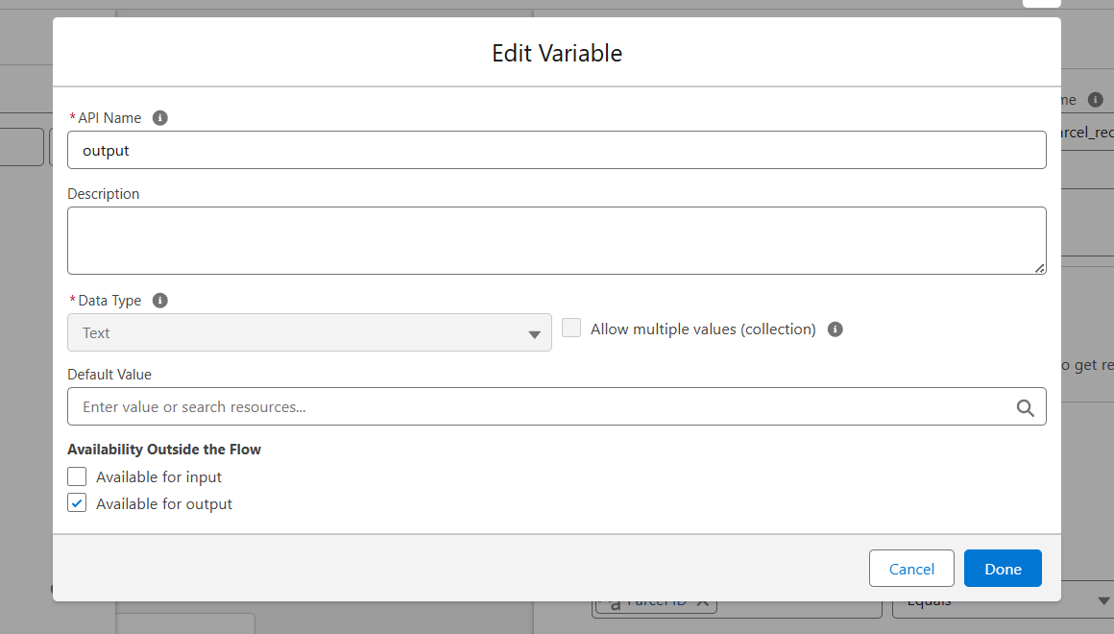
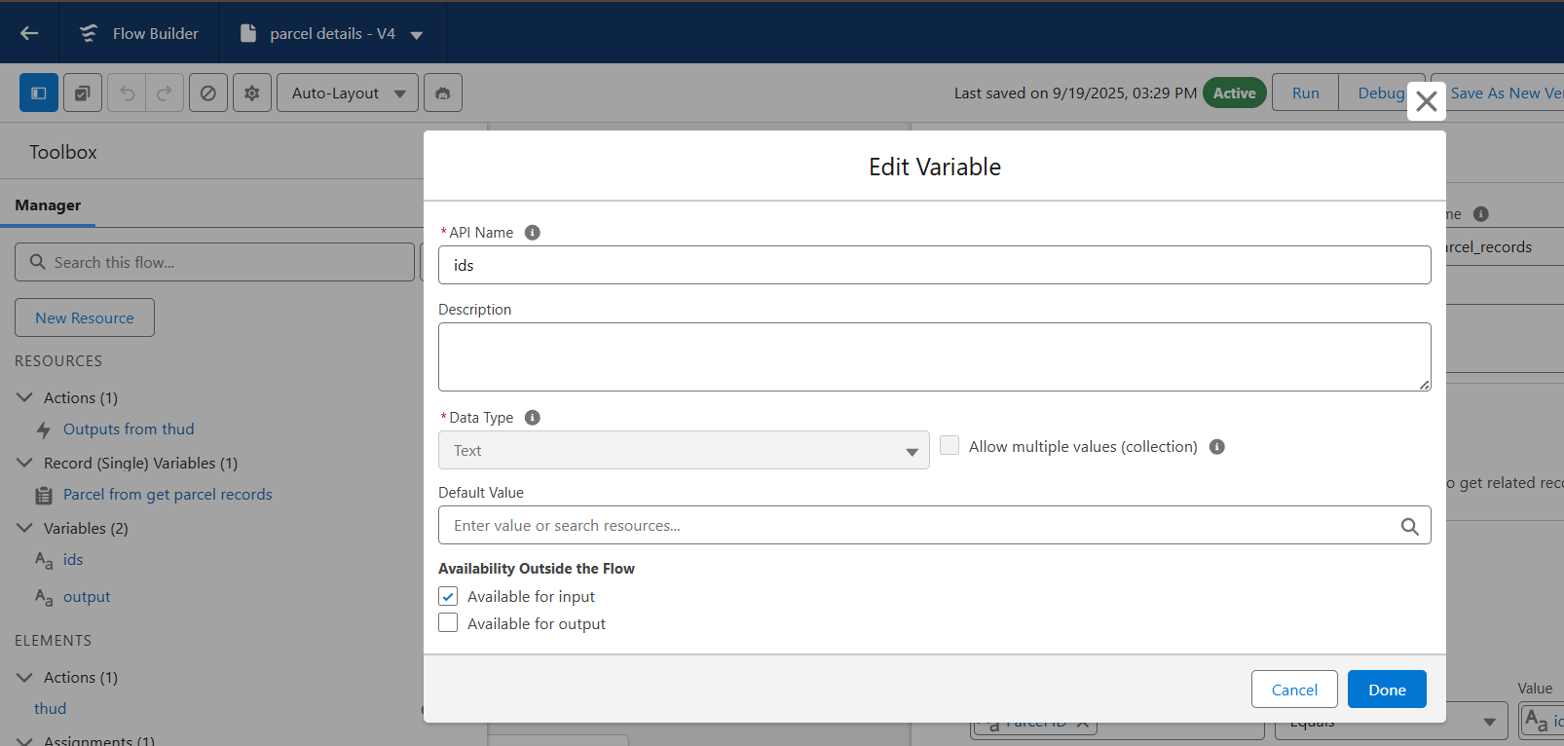

- Click on the Add icon to add Element: Get Records→ Label: Get Parcel Records

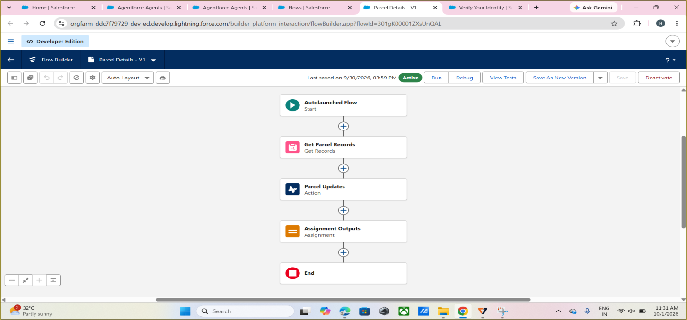
  - Object: Parcel
  - Field = Parcel_ID c
  - Operator = Equals
  - Value = ids
- Element : Action
Find Retrieve parcel details
Click Retrieve parcel details
  - Label: Parcel Updates.
  - Object To Summarize : Parcel from get Parcel records.

- Element : Assignment
  - Label: Assignment Outputs.
  - Variable= Output
  - Operator = Equals
  - Value = Outputs from Action>Prompt Response

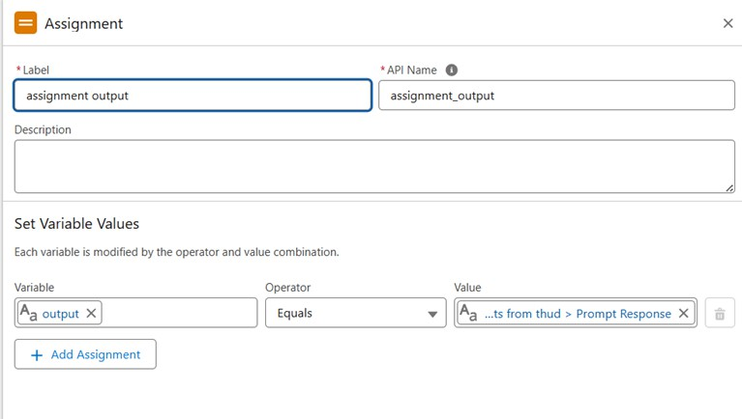
5. Connect Start → Get Records → Action → Assignment → End.
6. Save the Flow with the name Parcel Details.
7. Activate the Flow.
8. After saving the Flow, return to the Flows page. Click the dropdown next to the newly created Flow and select Edit Access.
9. At the top, locate Flow User Access. Assign the required available profiles and click Save.
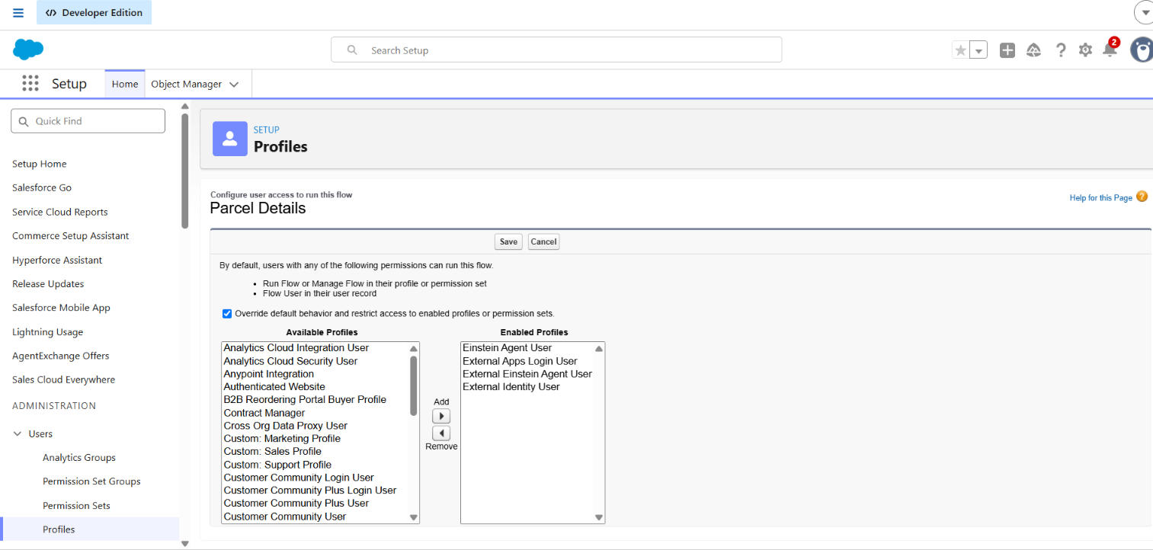

Phase 3: UI/UX Development & Customization

To enable agents to efficiently manage parcel operations while maintaining secure access control through Permission Sets and AI-powered agent experiences using AgentforceMilestone - 1 Creating Permission Sets
In the Quick Find box (left side), type Permission Sets.
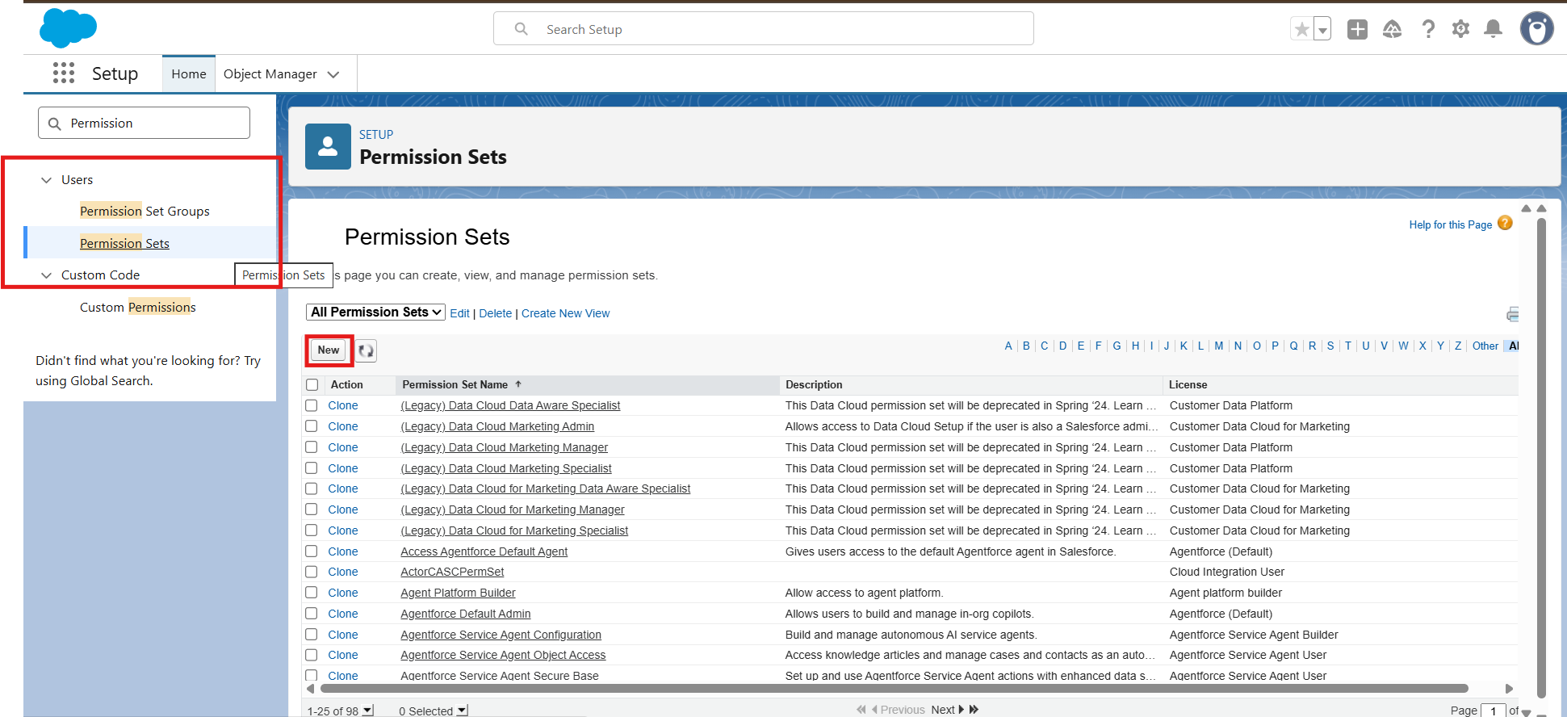
- Click Permission Sets under Users.
- Click the New button.
- Enter the following details:
- Label: Swift Ship
- API Name: auto-fills
- License: Choose Einstein Agent.
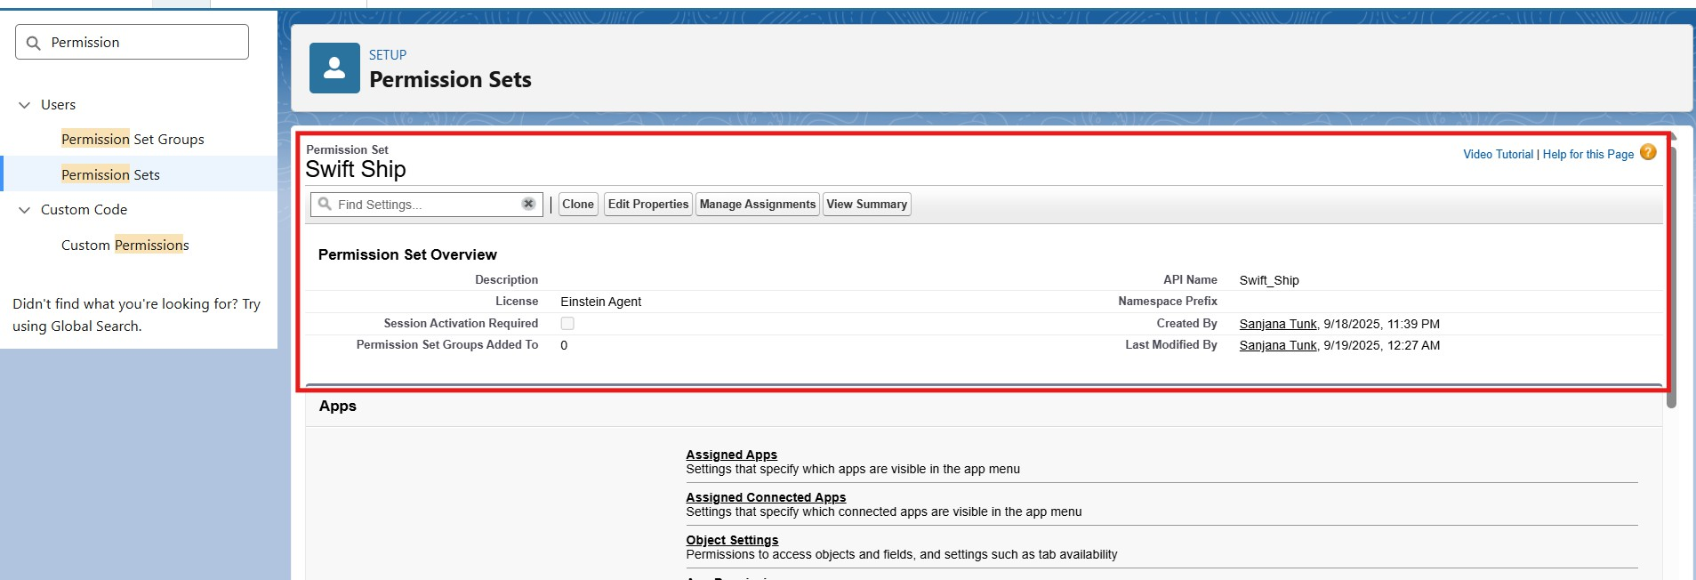
- Click Save.

- Inside the Permission Set page → under Apps → Object Settings, click Object Settings.
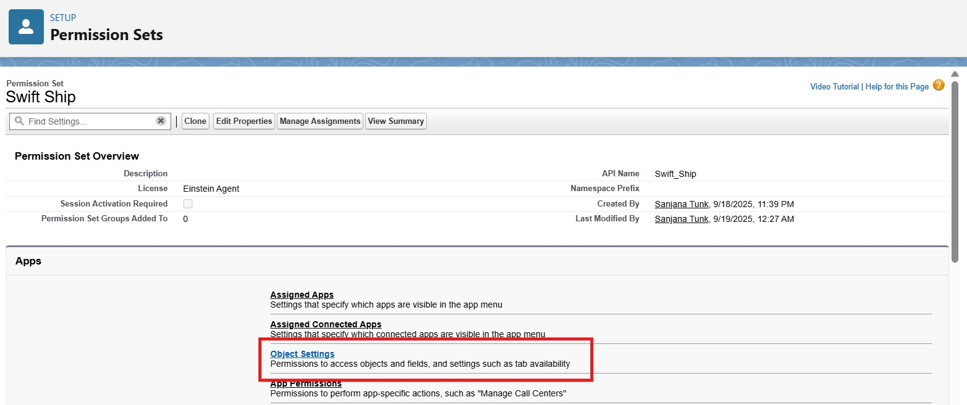
- Search and click each object one by one
- Click Edit.

Enable the following:
✅ Read
✅ Create
✅ Edit(Optional: Delete, if you want agents to remove records)
Under Field Permissions, ensure at least Visible is checked for all key fields. Click Save after each object.
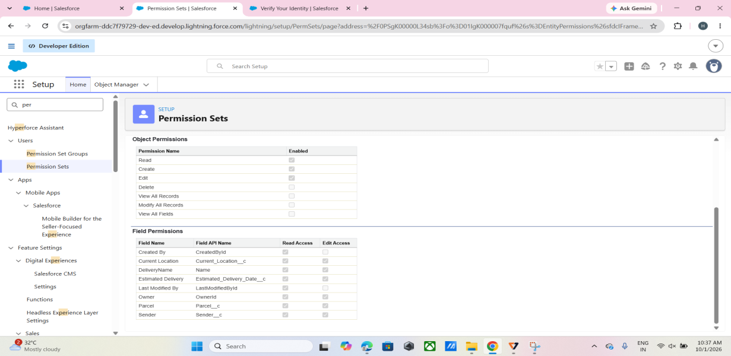
Parcel c

Delivery c
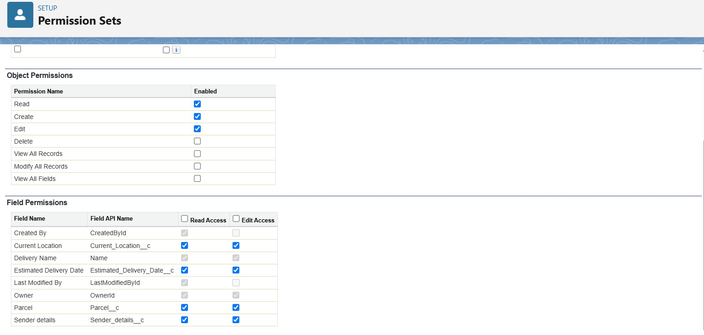

Sender c

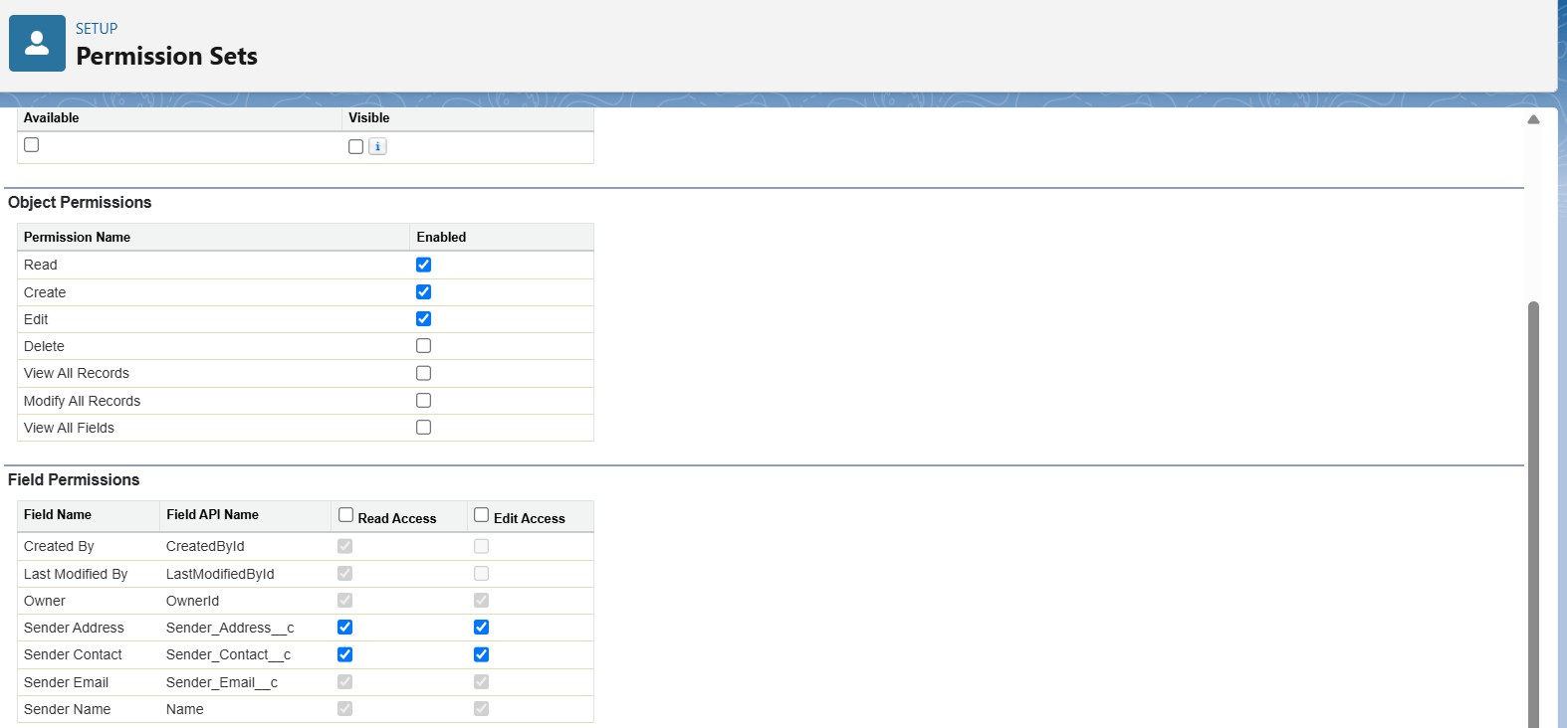
Receiver c
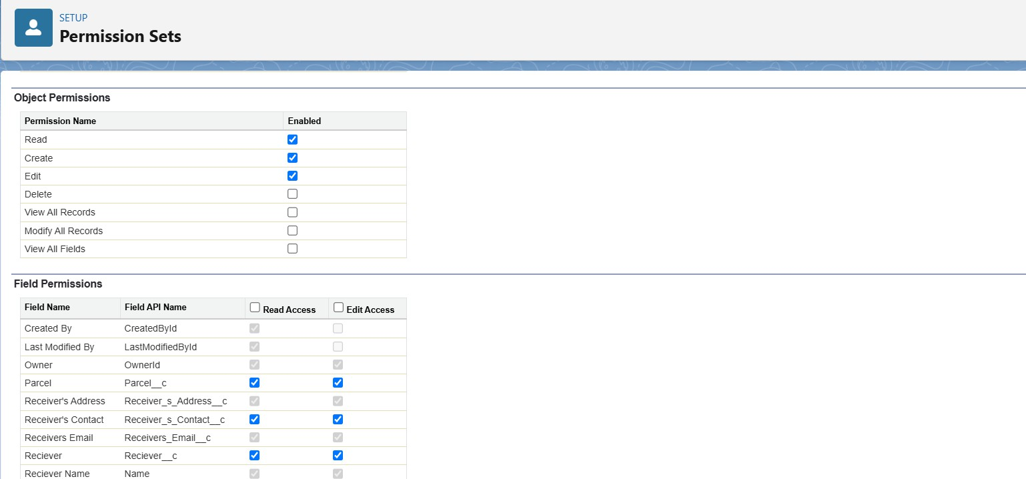

Milestone - 2 Assigning Permissions to your Agent user
In the Quick Find box on the left side, search for Users.
- Click Users under the Users section.
- Open the Agent User Record
From the list of users, find the Einstein Service Agent user to represent your Agent (e.g., “SwiftShip Agent”).

Click on the Full Name of that user to open the record.

- Scroll down to the section named Permission Set Assignments.
- Click the Edit Assignments button.
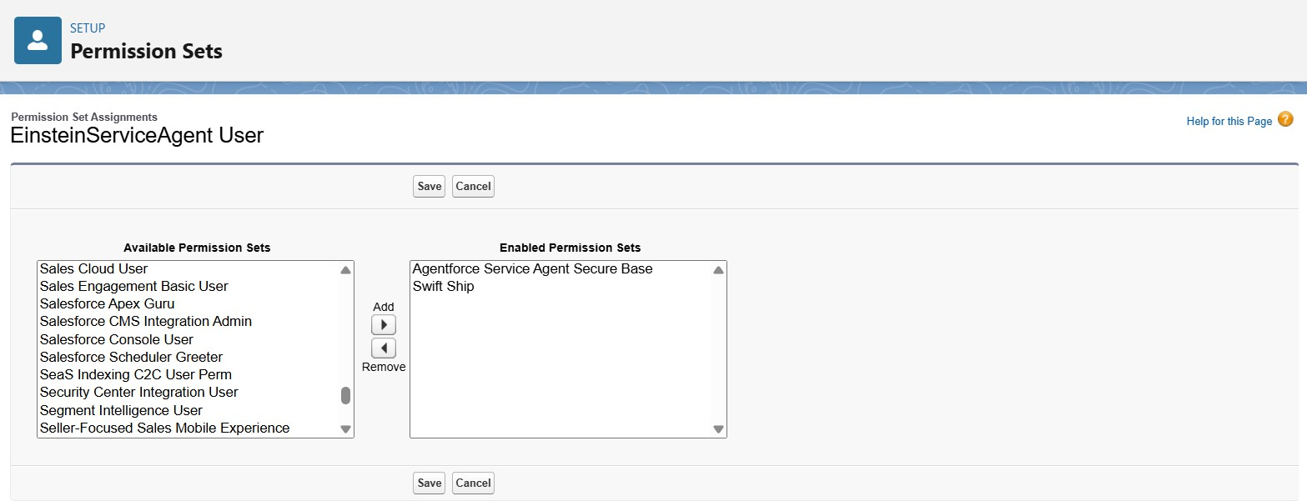
- On the left side (Available Permission Sets), find and select your permission set:
  - SwiftShip

Click the Add → button to move it to the right-side list (Enabled Permission Sets). Click Save.
Milestone 3 – Org Setup for Agentforce

Enable the Salesforce Default Agent from Salesforce Go
- In the Quick Find box, search for Salesforce Go and click it.
- Search for Default Agent.
- Click Get Started and turn on the agent.
- Refresh the page.
Enable Einstein Setup
- Go to Setup and use the Quick Find box to search for Einstein Setup.
- Open Einstein Setup and click Get Started if prompted.
- Turn on the following key services:
  - Turn On Einstein
  - Global Languages
  - Deploy Prompt Template

Agentforce Configuration
- Refresh the browser page.
- Go to Setup → Quick Find → Agentforce Agents.
- Turn on the following key services:
  - Agentforce
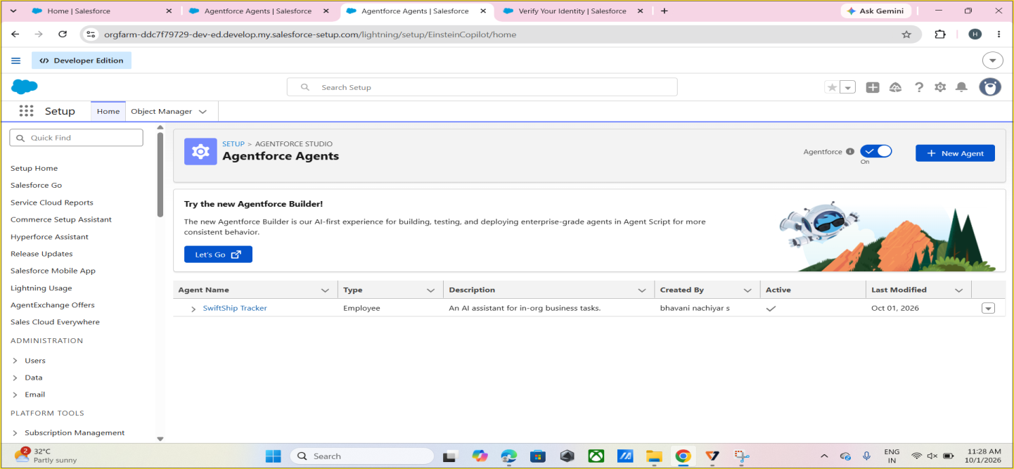
  - Enable Agentforce Default Agent

Milestone 4 – Building the Agent

- In Setup, use the Quick Find box to search for Agentforce Agents.
- Click Agentforce Agents.
- Select the Default Agent.
- Click Open in Builder.

Assign Sub Agents to the Agent
On the subagents Click on New.
  - Click New Subagent
2. Create a new subagent.
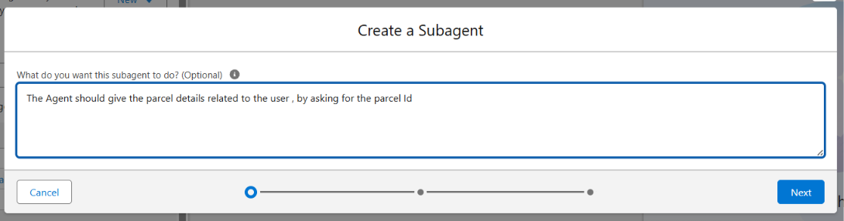
3. Fill in the details as shown.

Adding Actions to Agentforce Assets
While still on the Agent Builder in the topics,
- Click on the Topics Actions
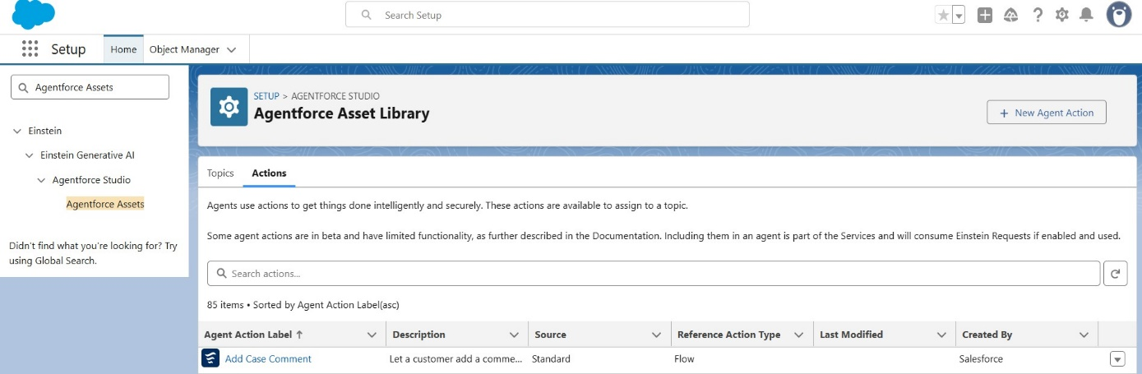
  - Click on New Agent Action.
  - For Action type, Click on Flow then Next.

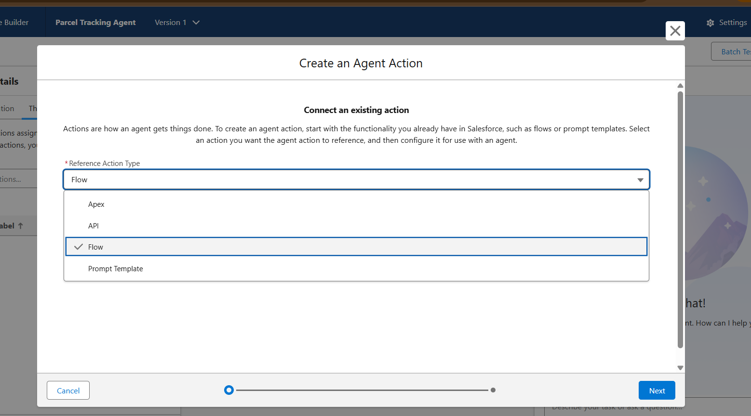
- For Reference, Flow use the recently created flow, click Next.
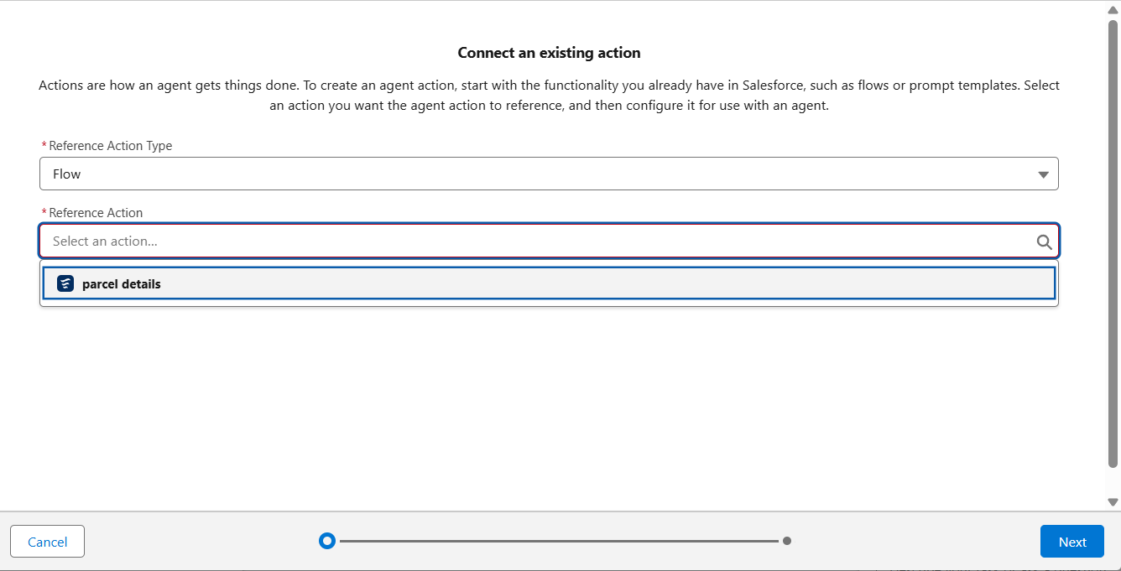
- Fill the details for Agent Configurations.

Assign Subagents Action

While on the Agent Builder in Subagent, Click on the Parcel Updates Subagent

Click on the subagents Actions, then select A from asset library.

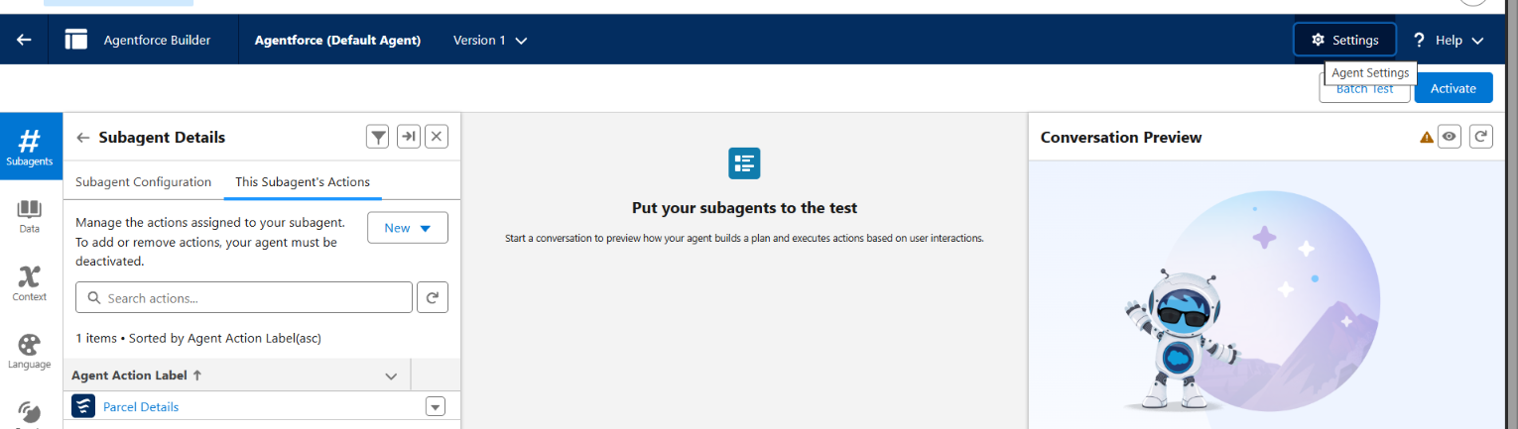
Select the flow action that we created and click on finish.

Click on settings , and rename your agent to SwiftShip Tracker

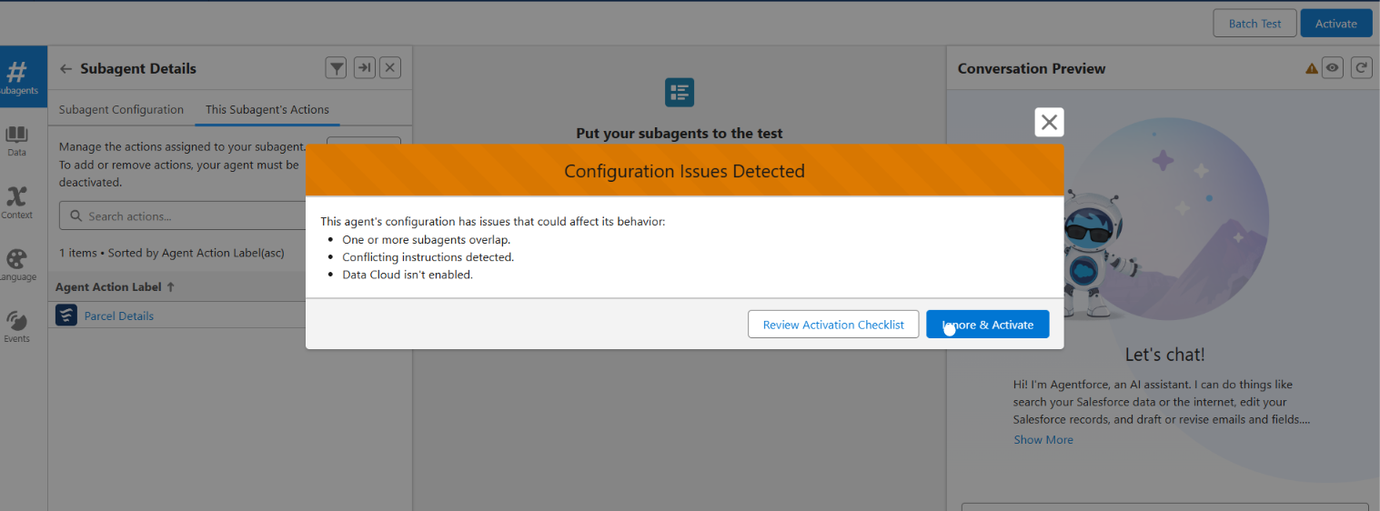
Click Save.

- Click on Ignore and Activate, then Activate.

Phase 4: Data Migration, Testing & Security

This phase focuses on validating the functionality and reliability of the Parcel Tracking Agent created in Agent Builder. It ensures that the agent correctly identifies topics, triggers the assigned SwiftShip Tracker Flow, retrieves or updates parcel information, and performs the intended actions without access or permission issues. The objective is to confirm that the AI-powered agent operates smoothly within Salesforce and provides accurate, real-time responses to parcel management queries.

Verify Agent
Go to Setup → Agentforce Agents.
- Open the Agents list and confirm that your agent Name: Parcel Tracking Agent, appears
2.Validate Assigned Topic

- In Agent Builder → SubAgent, verify that the SubAgent you created, such as Parcel Tracking or SwiftShip Tracker, is listed.
- Open the topic and verify the following:
  - It contains a prompt or description related to parcel management.
  - The Action/Flow (SwiftShip Tracker) is linked to the topic.
- Click Save and confirm that the topic is Active.

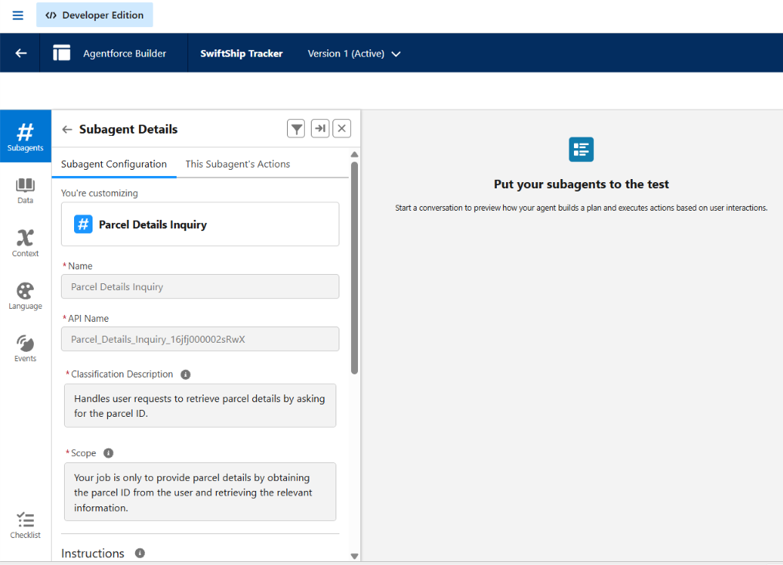
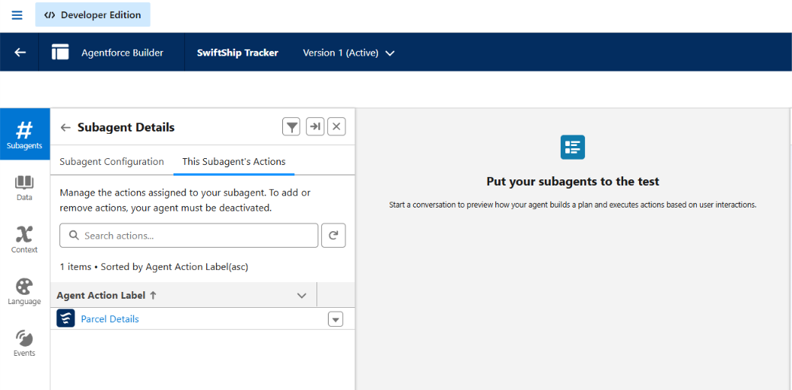

Check the Flow Association
Go to Setup → Flows.

- Locate the Flow named SwiftShip Tracker.
- Confirm:
  - The Flow is Activated.
  - The Flow includes screens or actions that handle:
    - Parcel ID input
    - Parcel details retrieval
    - Status update or confirmation message
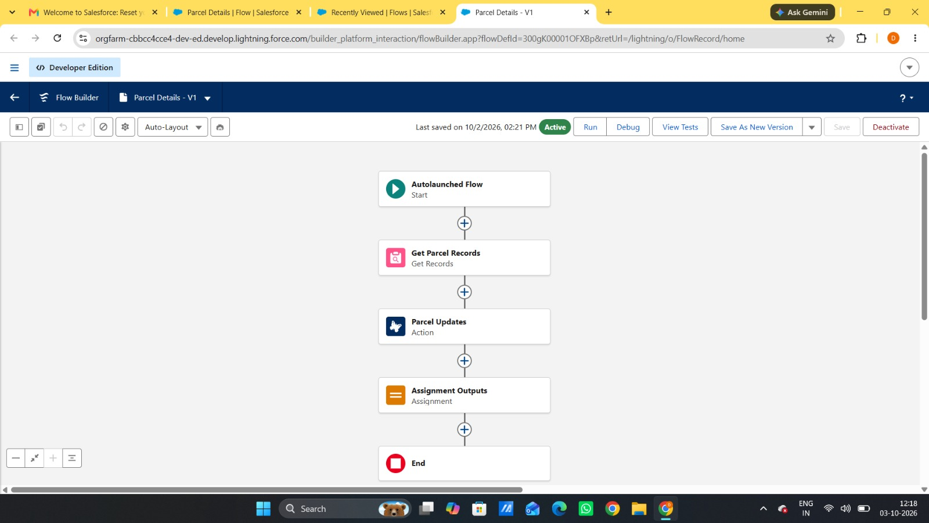
- Open the Flow’s Advanced Settings → ensure Run in System Context

Activate and Test the Agent

- Return to Setup → Agent Builder → Parcel Tracking Agent.
- Click Activate (if not already activated).
- Once active, test using Preview / Try it Out mode: Type a query such as:
“Track parcel ID P12345” or
“Update delivery status for parcel P67890 to Delivered.”
- Observe the agent’s response.

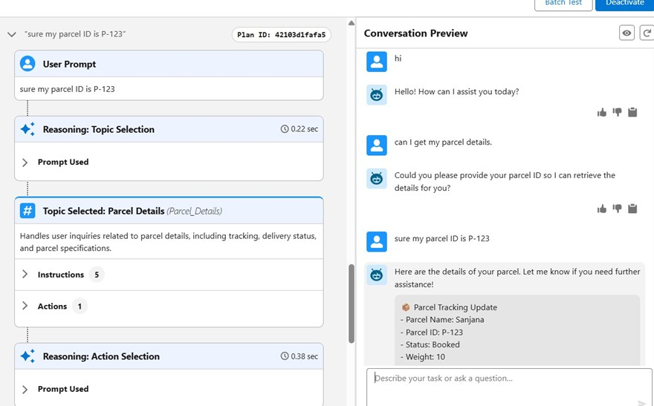

Validate Data in Salesforce
- After the agent runs the Flow:
  - Go to App Launcher → Parcels (Parcel c).
Search for the Parcel ID you used during testing. Verify:
  - The Status or related field is updated.
  - Any Flow-created records (bookings, updates) appear correctly.

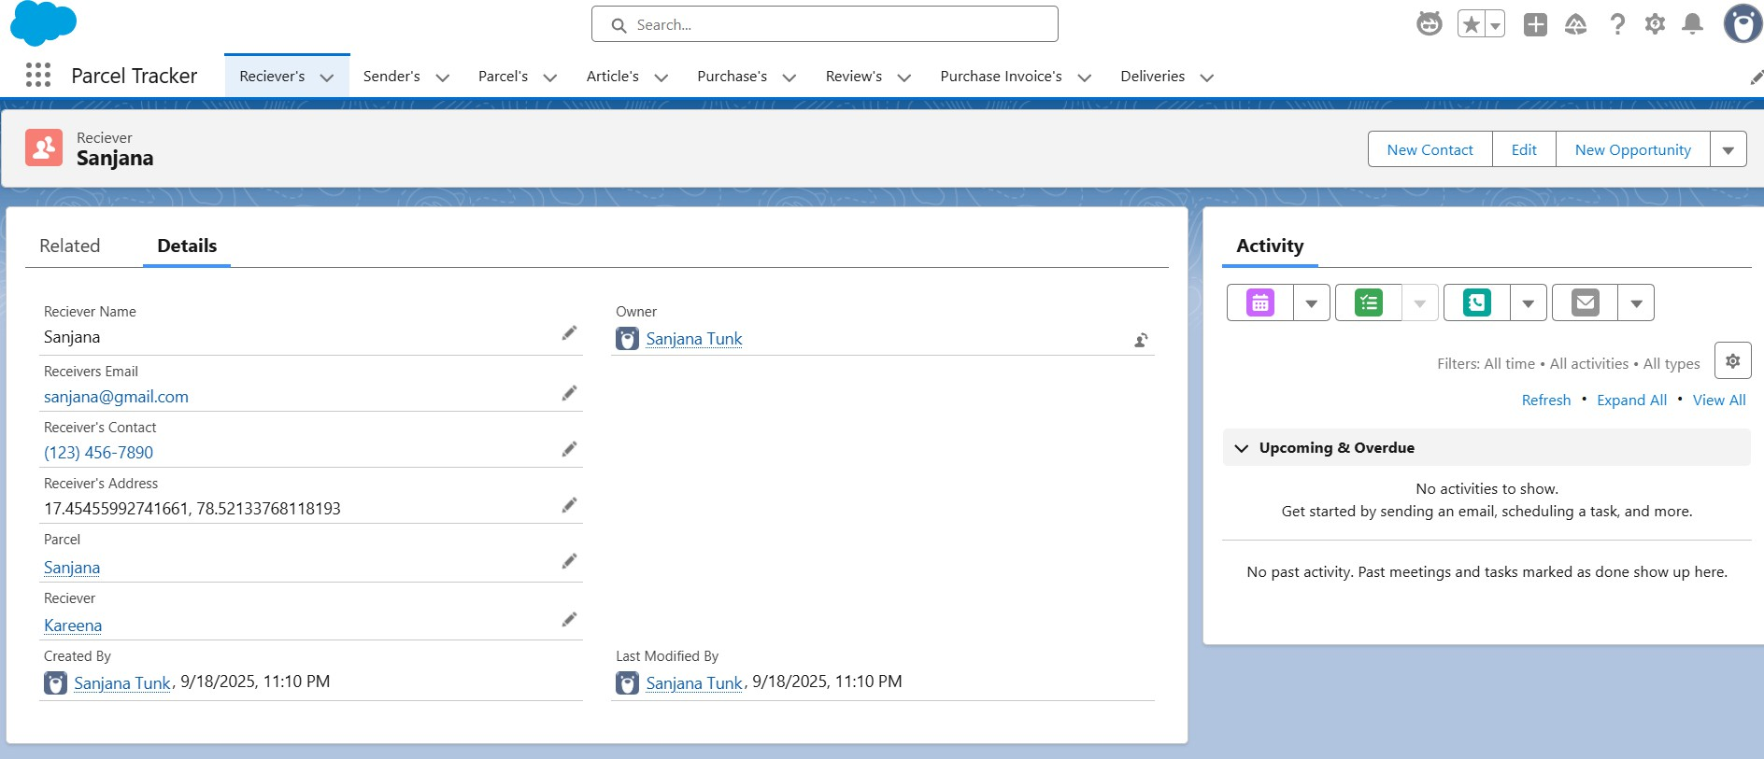

Phase 5: Deployment, Documentation & Maintenance
Within the scope of the SwiftShip Tracker (Agentforce) project implementation:
- The purpose of this phase is to validate that the Parcel Tracking Agent, created using Salesforce Agent Builder, functions as intended within the Salesforce Developer Org environment.
- The main objective is to test how an AI-powered Service Agent performs key tasks such as topic recognition, Flow execution, and data retrieval from Salesforce custom objects.
- Testing is carried out within the Developer Org to simulate the agent's behavior in a live environment and verify that permissions, Flows, and agent interactions work correctly before deployment.
- Real-world production testing, such as User Acceptance Testing (UAT) or sandbox deployment, is not performed as part of this project because:
  - Developer Edition orgs are standalone environments and do not provide production-linked testing environments.
  - Enterprise-level Agentforce deployment typically involves sandbox testing, staging environments, and CI/CD automation, which are beyond the scope of this academic/prototype implementation.

Maintenance, Monitoring & Troubleshooting

In the SwiftShip Tracker (Agentforce) project, ongoing maintenance helps ensure that Parcel, Customer, and Delivery data remains accurate, synchronized, and up to date.Regular monitoring is carried out to identify issues such as incorrectly routed agent queries, failed Flow executions, or delays in Agentforce responses.Troubleshooting activities include resolving configuration issues, updating Flow logic, refining agent topics, and improving prompts to provide smoother and more effective user interactions.

Although this project is implemented within a Salesforce Developer Org for learning purposes, in real-world enterprise deployments, these maintenance and monitoring practices are essential. They ensure that AI-powered service agents remain reliable, scalable, and continuously aligned with evolving customer service operations and business goals.
1. FUNCTIONAL & PERFORMANCE TESTING
During testing, screenshots were captured from Salesforce to verify key functionalities such as parcel creation, customer and delivery details, parcel status updates, Flow execution, Agentforce interactions, data retrieval, notifications, and dashboard analytics. All major features were tested to ensure that the system functions correctly and provides reliable performance.
2. ADVANTAGES & DISADVANTAGES
Advantages
- Centralizes parcel, customer, sender, receiver, and delivery information in Salesforce.
- Provides improved visibility into parcel booking and delivery tracking.
- Automates important logistics processes using Salesforce Flow.
- Agentforce provides conversational customer support and parcel-status assistance.
- Prompt Builder enables AI-powered responses and self-service capabilities.
- Reduces manual effort for customers, support teams, and administrators.
- Provides timely notifications and updates throughout the delivery process.
- Experience Cloud provides customers with convenient access to parcel tracking information.
- Supports integration with external logistics and delivery systems.
- Can be expanded to support multiple locations and growing parcel operations.
Disadvantages
- Requires accurate and up-to-date parcel and customer information.
- Depends on proper Salesforce configuration and automation.
- Agentforce responses depend on correctly configured prompts, topics, and available data.
- Integration with external logistics systems may increase implementation complexity.
- Flows and automation logic require regular maintenance when business processes change.
- Users require appropriate Salesforce or Experience Cloud access to use the system.
- Initial Salesforce implementation and configuration may require considerable effort.
- Expanding the system to additional locations or integrations may require further customization

CONCLUSION
The SwiftShip Tracker project demonstrates how Salesforce can be used to develop a centralized parcel management and tracking solution. The system integrates custom objects, relationships, Salesforce Flows, Apex, Email Alerts, Experience Cloud, Agentforce AI, Prompt Builder, security controls, reports, and dashboards to support parcel booking, delivery tracking, status updates, and customer communication.
The integration of Agentforce AI, Prompt Builder, and Salesforce Flow provides a conversational approach to parcel tracking. Customers can obtain shipment information through AI-powered interactions without relying entirely on manual support. Overall, the project provides a practical foundation for developing a scalable, secure, and user-friendly parcel management solution.
4. FUTURE SCOPE
- Extend Agentforce capabilities to support additional parcel-management queries.
- Enhance real-time delivery and shipment tracking.
- Expand customer self-service capabilities through Experience Cloud.
- Introduce more advanced delivery-performance analytics.
- Integrate additional external logistics and transportation systems.
- Improve AI prompts and conversational agent experiences.
- Implement enterprise-level sandbox testing and CI/CD deployment.
- Expand automation to cover additional parcel-management operations.
- Strengthen continuous monitoring and maintenance of Flows and AI-agent functionality.
- Further improve prompt configuration and agent scalability.
The project can be further enhanced through enterprise deployment practices, continuous monitoring, prompt refinement, Flow improvements, and expansion of AI-agent capabilities.
5. APPENDIX
A. Custom Objects
- Parcel
- Delivery
- Sender
- Receiver
B. Standard Objects
- Account
- Contact
- Case
- Task
- EmailMessage
- User

C. Automation
- Salesforce Flows
- Approval Processes
- Email Alerts
D. Apex
- Apex Classes
- Batch Apex
E. AI
- Agentforce AI
- Prompt Builder
F. User Interface
- Lightning App
- Lightning Record Pages
- Experience Cloud
G. Security
- Profiles
- Roles
- Permission Sets
- Sharing Rules
- Field-Level Security
H. Analytics
- Reports
- Dashboards
I. Testing
- Flow validation
- Agentforce testing
- Data retrieval validation
- Security and permission validation

Thank You

